**Introduction:**

I was given the task of developing a website for wild swimming and camping .For developing websites I will be using HTML,CSS,PHP and javascript.This website has to be dynamic and responsive, users can log in and book camping.

**Task-1 HTML**

Developed seven html pages for this website using HTML . the pages are show blow :-

* **All Pages:**



Figure 1:virtual layout of seven pages

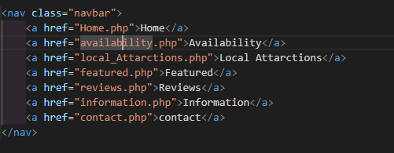

Figure 2:code layout of seven pages

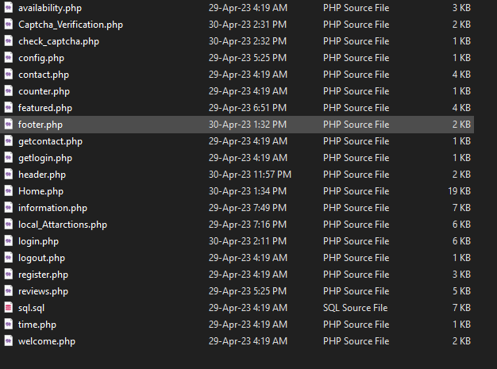

Figure 3:All files in php format.

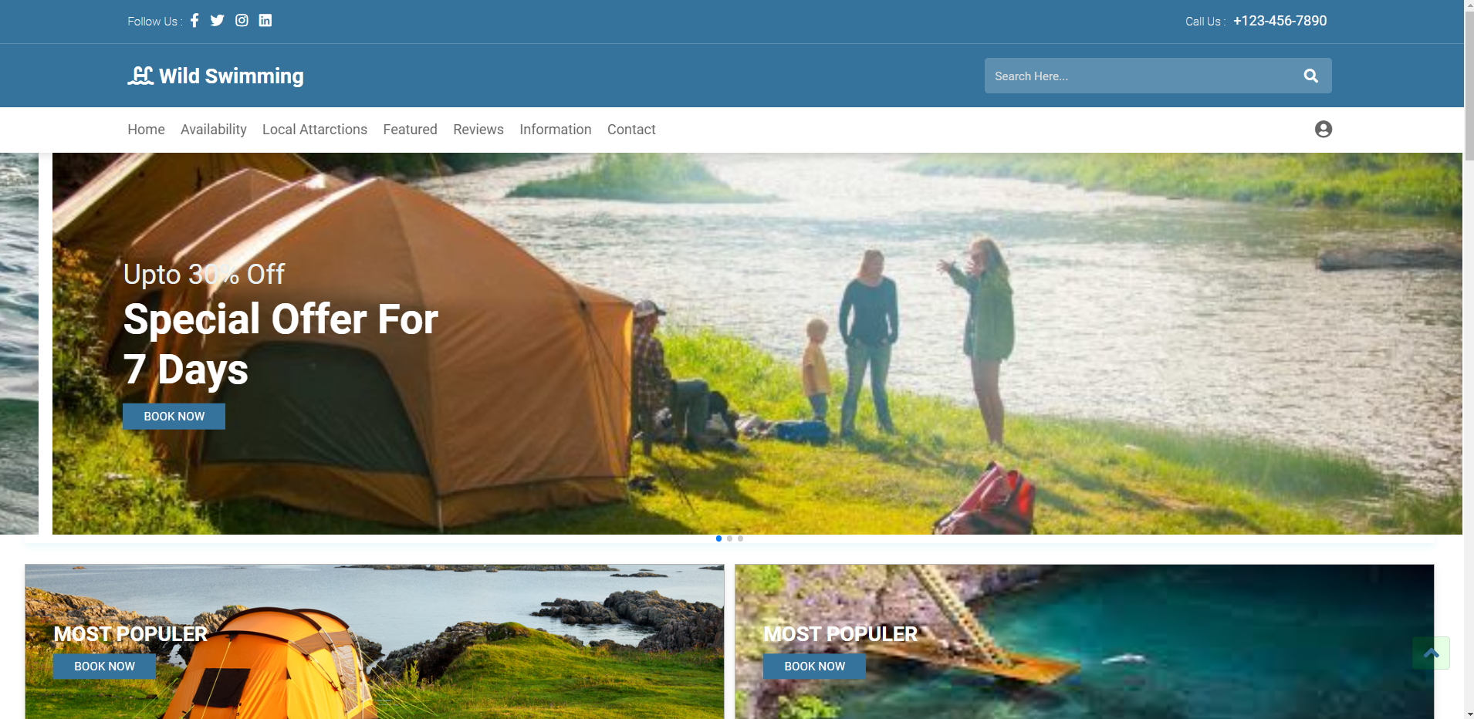

Figure 4:Home page user interface.

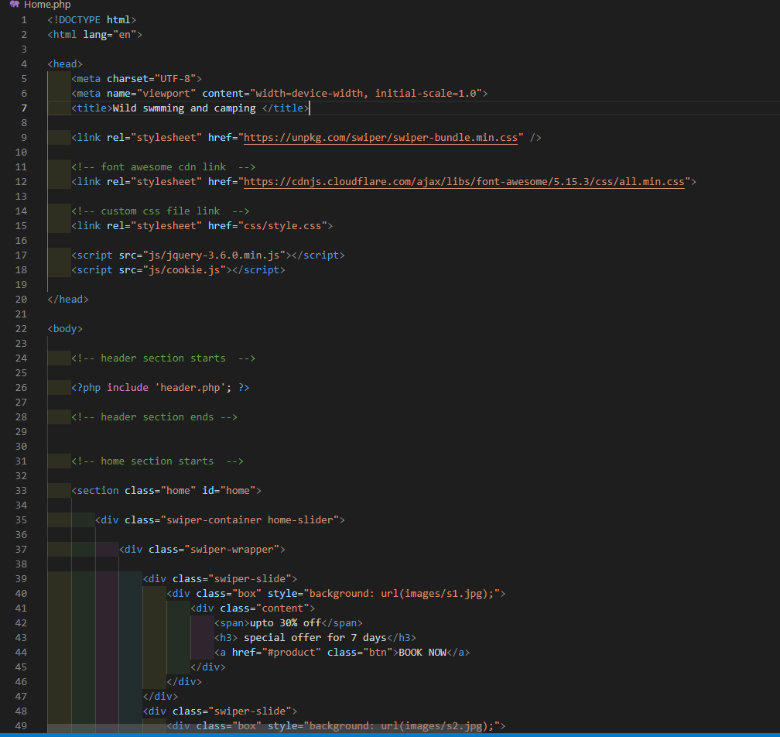

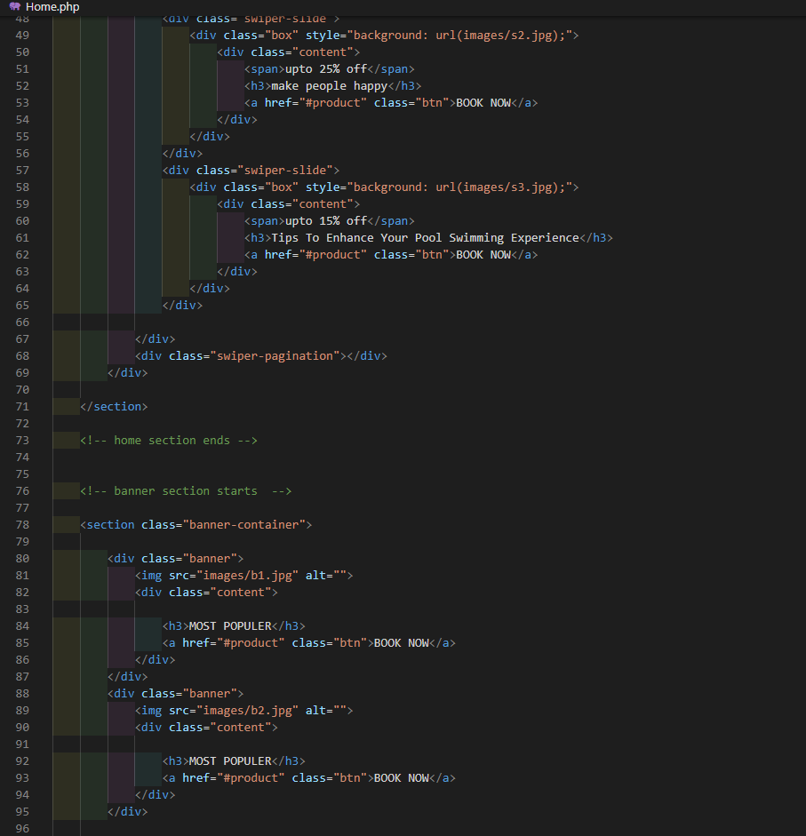Figure 5:Home page code.

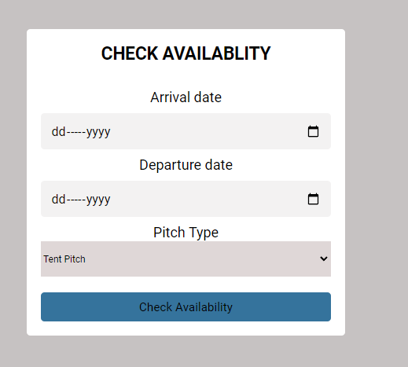

Figure 6:Availability page.

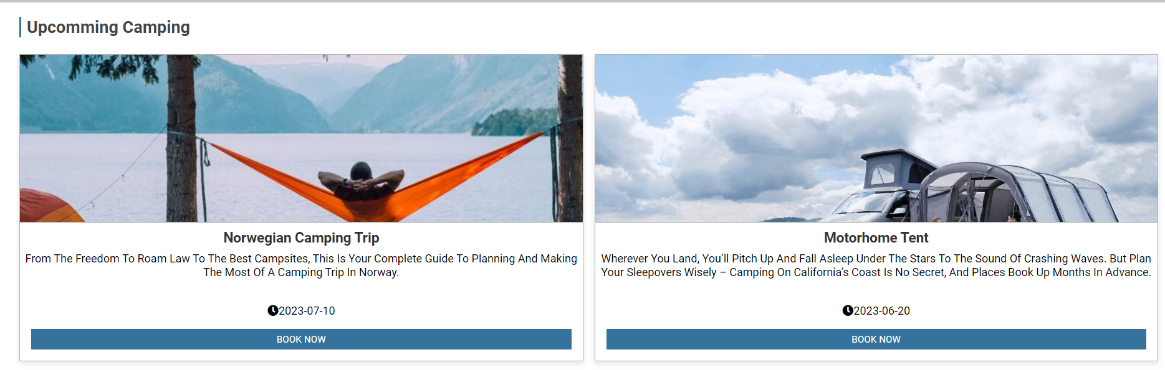

Figure 7:Availability page fetch data from database .

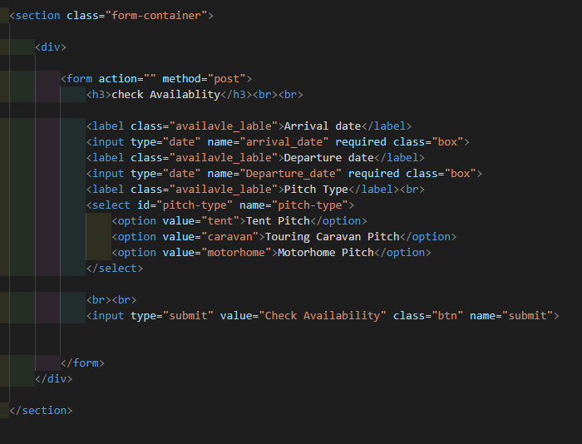

Figure 8:Availability page HTML.

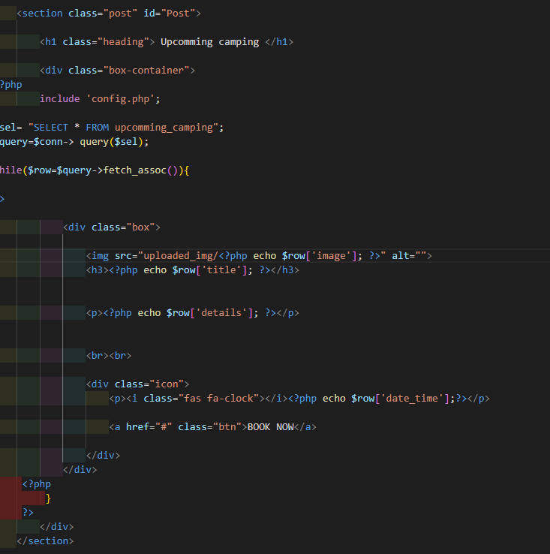

Figure 9:Availability page fetch data from database Code.

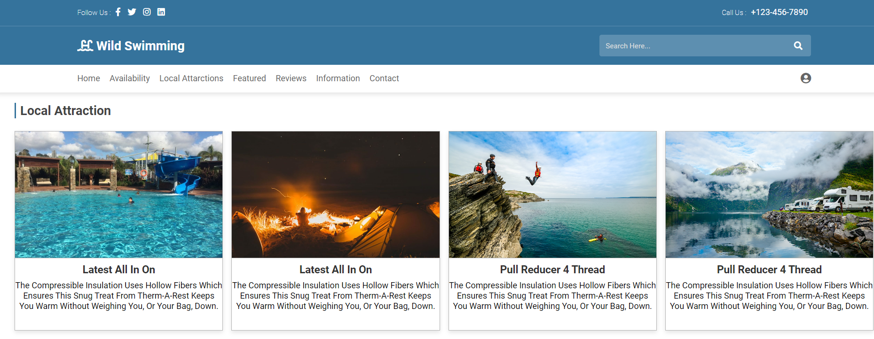

Figure 10:Local attraction page user interface.

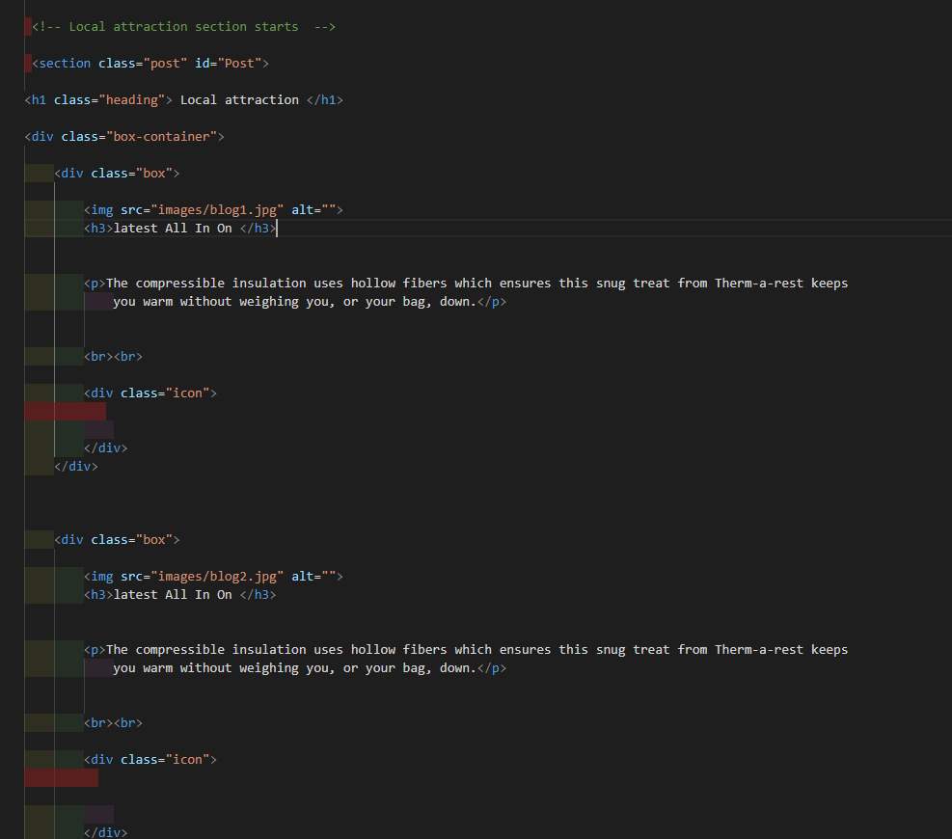Figure 11:Local attraction page HTML Code.

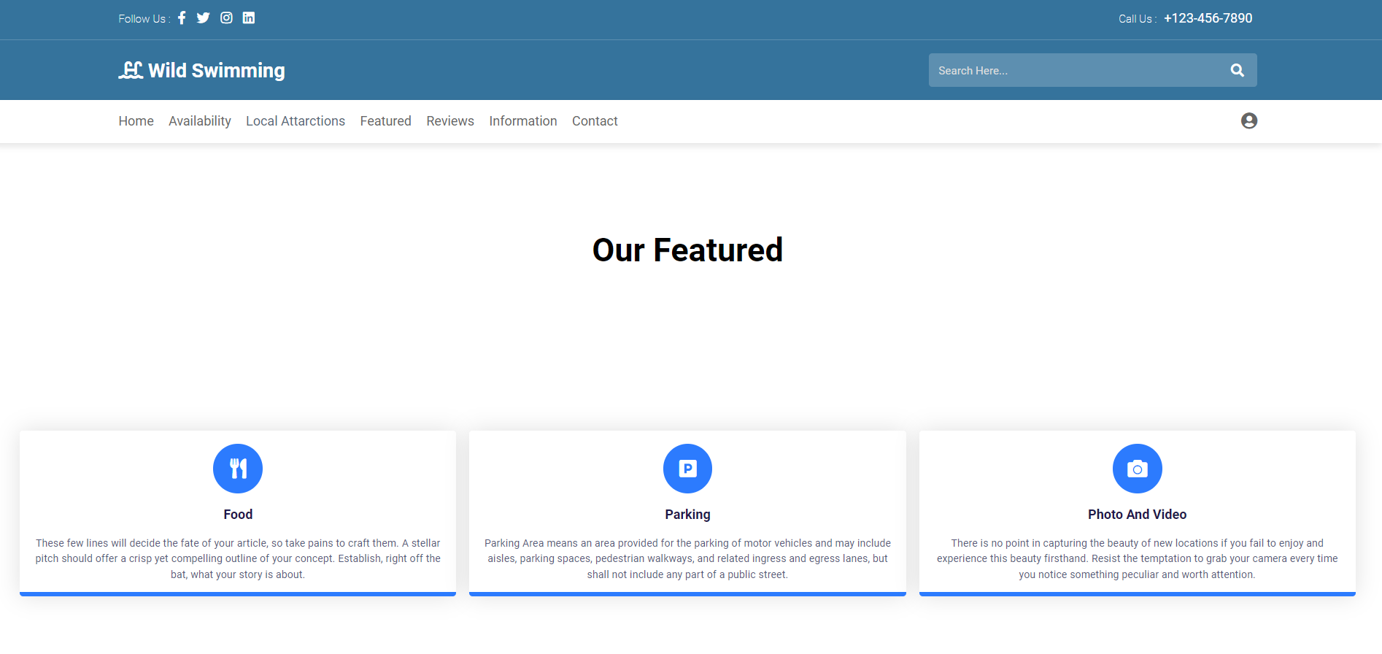

Figure 12:Featured page.

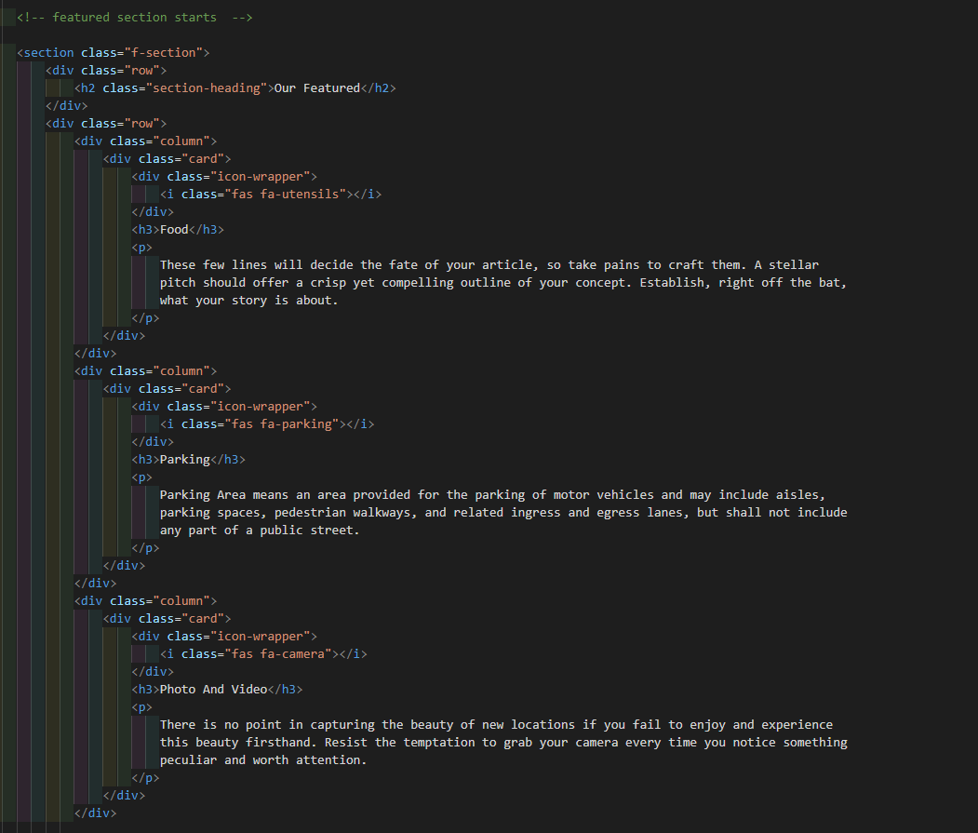

Figure 13:Featured HTML Code.

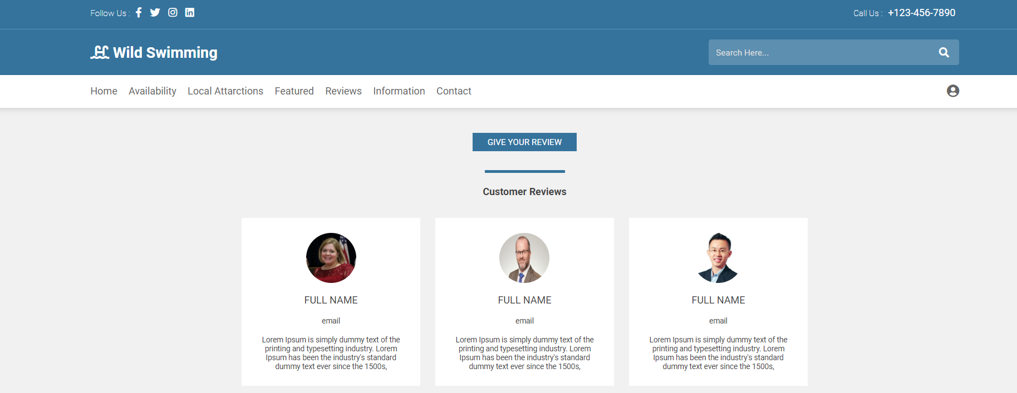

Figure 14: reviews page.

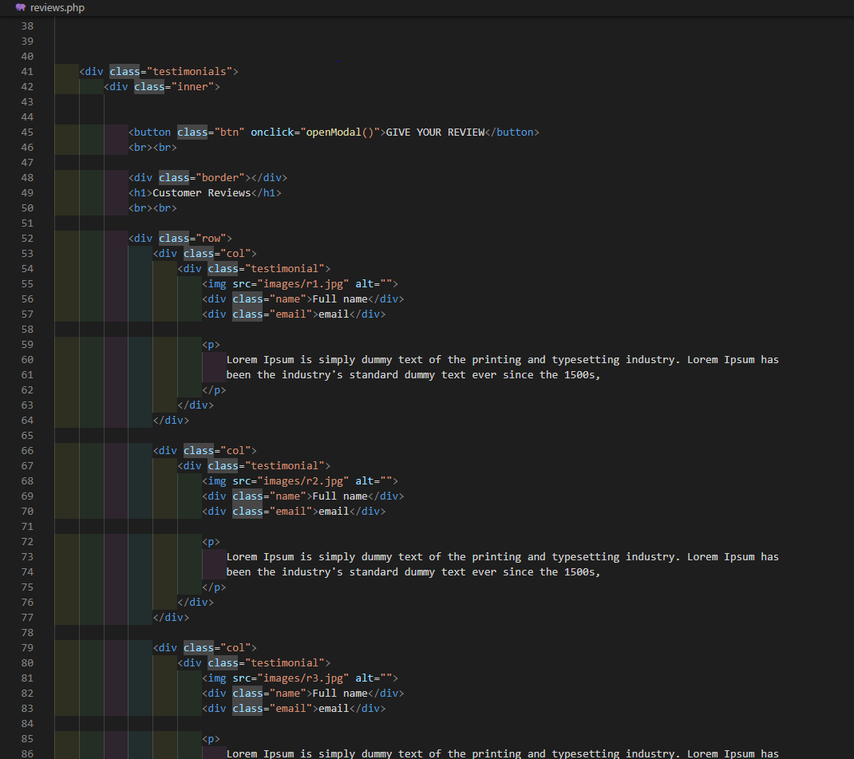

Figure 15 :reviews page HTML code.

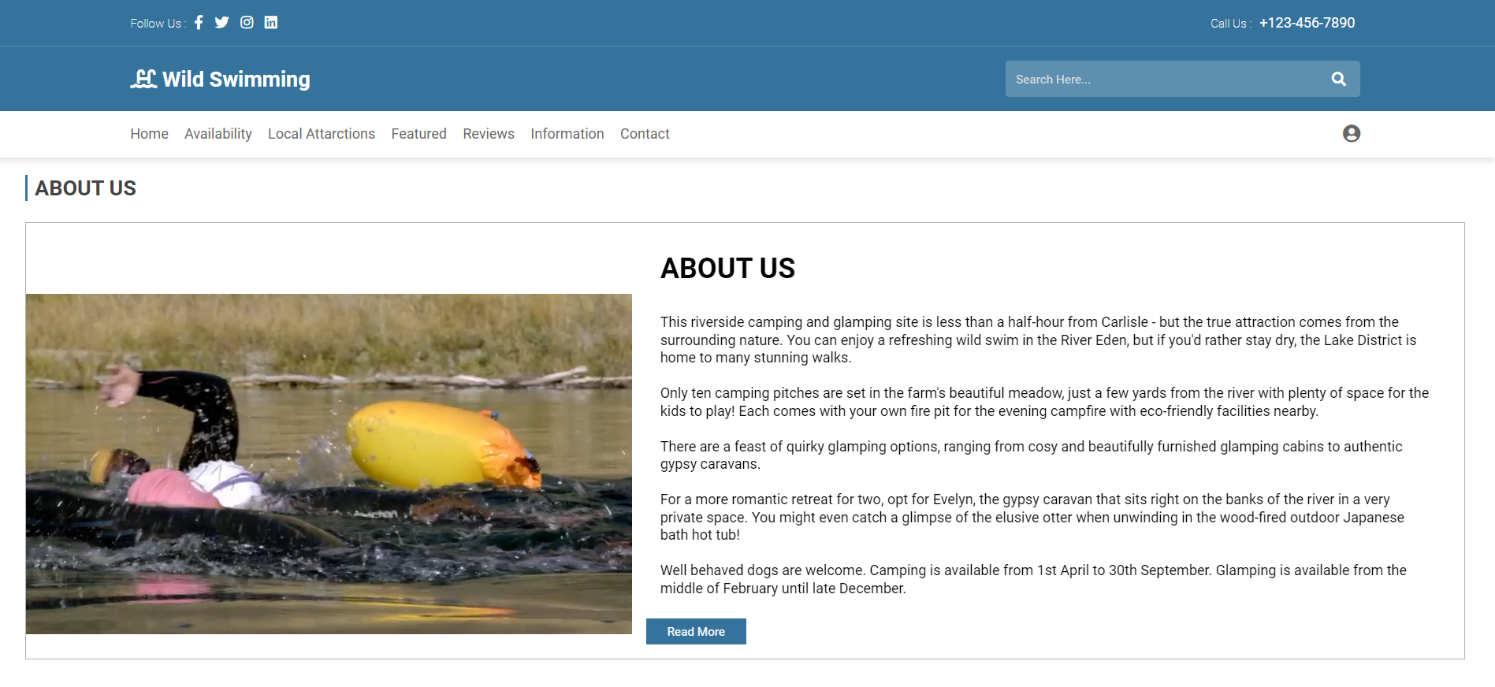

Figure 16:Information page

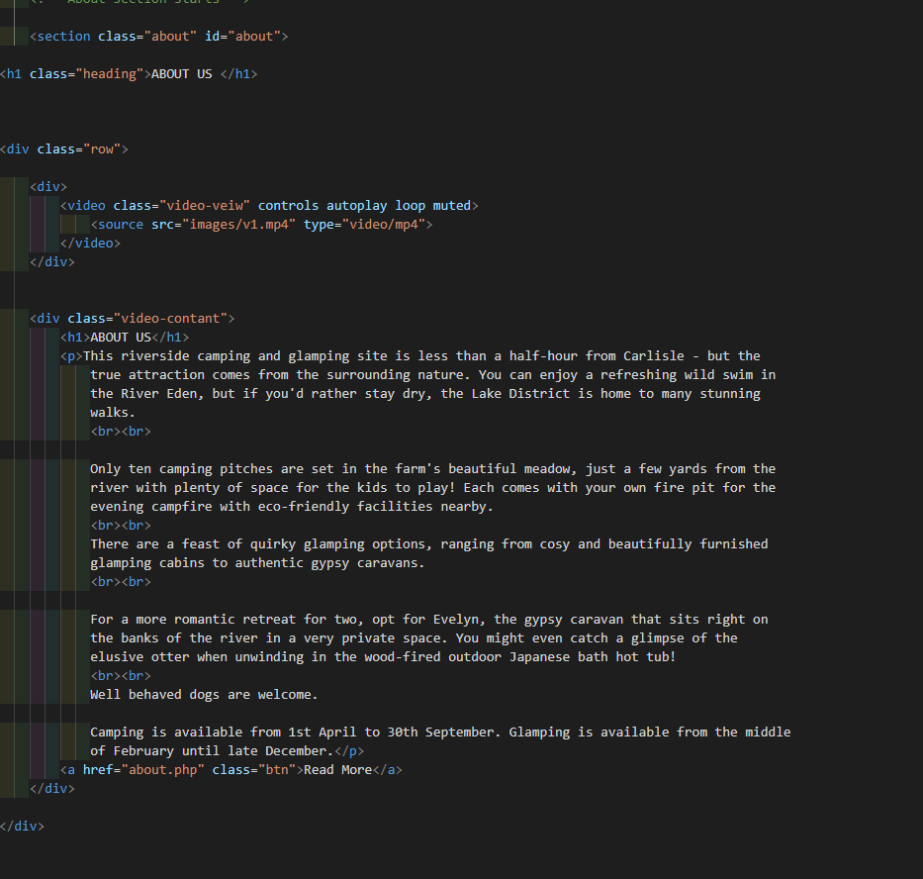.Figure 17:Information page HTML code.

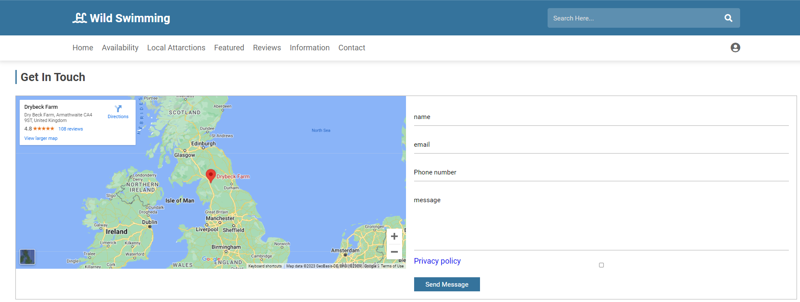

.Figure 18:contact page .

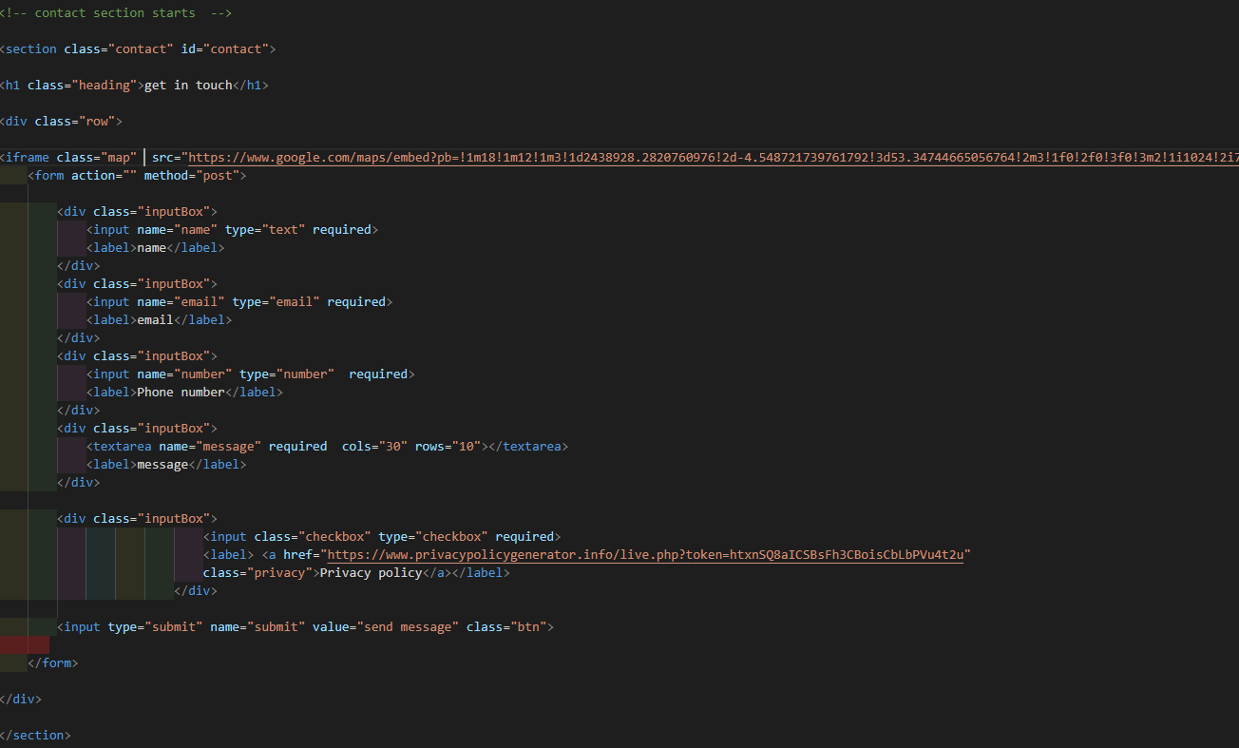

.Figure 19:contact page HTML code.

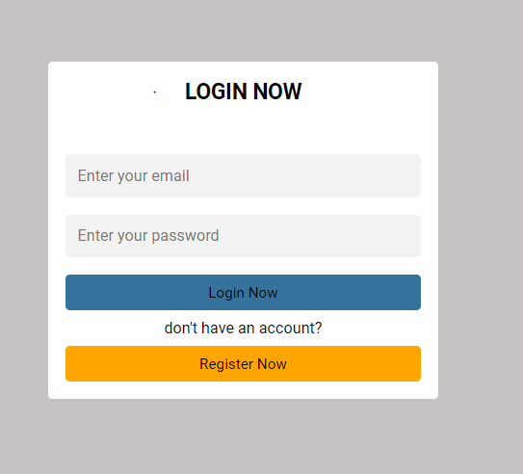

.Figure 20: Login page .

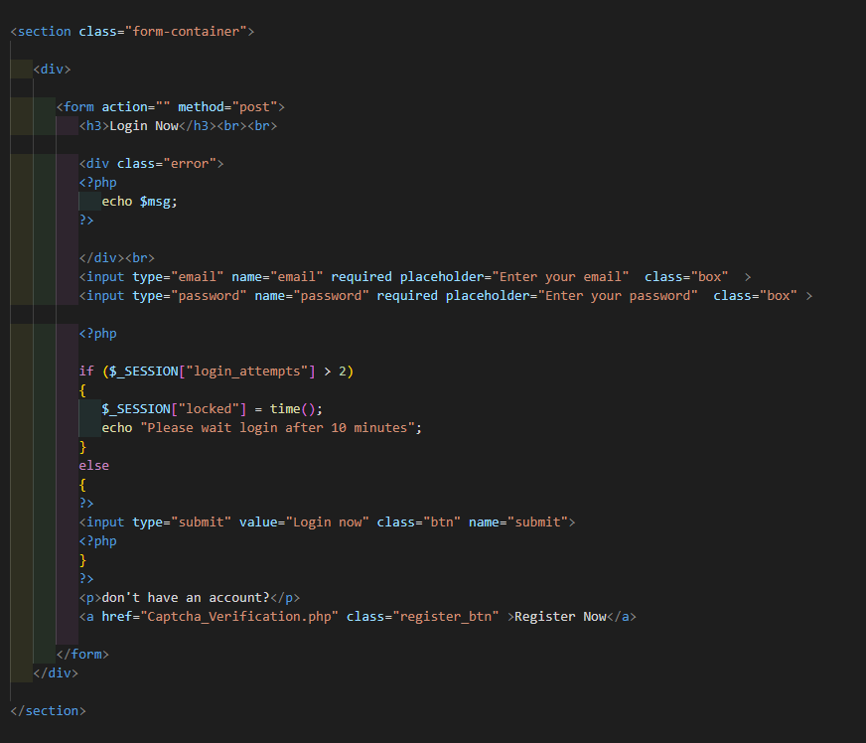

.Figure 21: Login page HTML code..

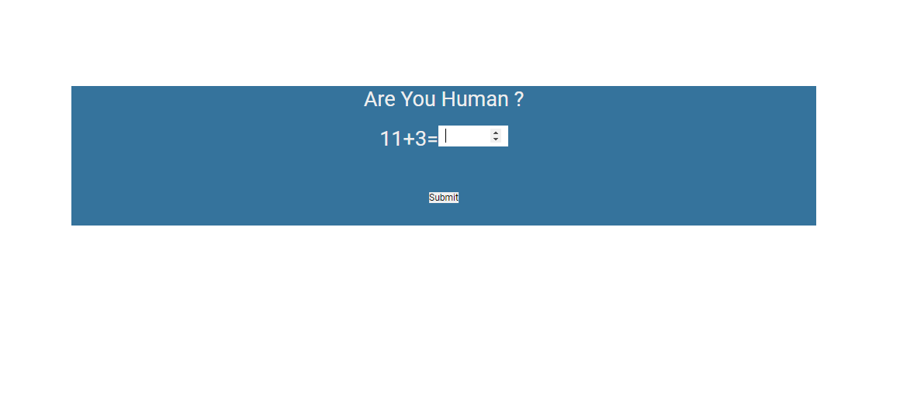

.Figure 22:captcha verification.

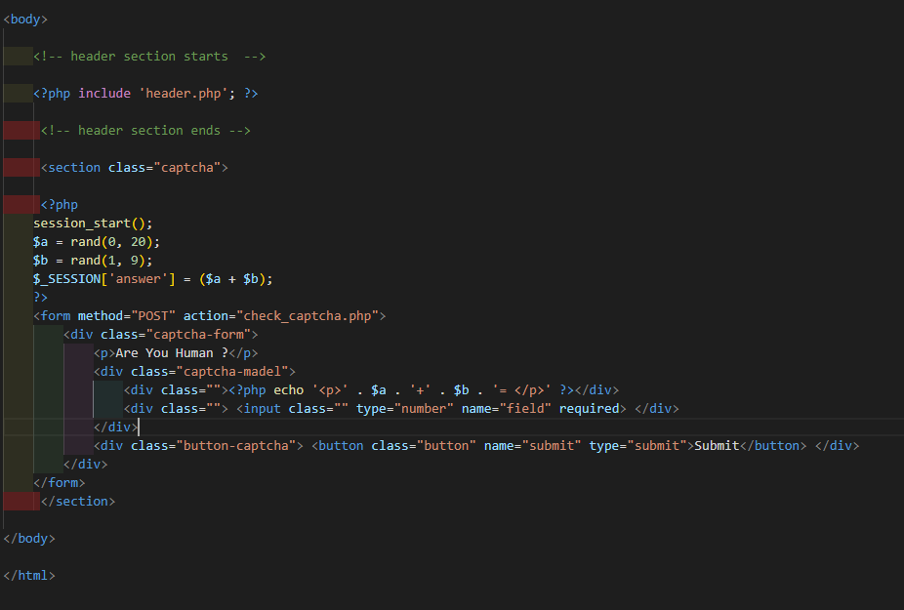

Figure 23:captcha verification HTML Code.

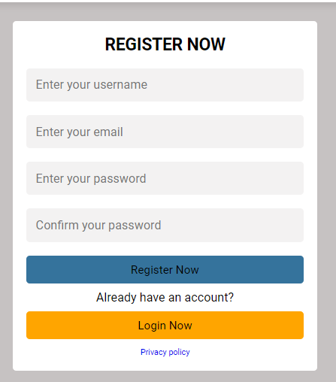

Figure 24:signup page.

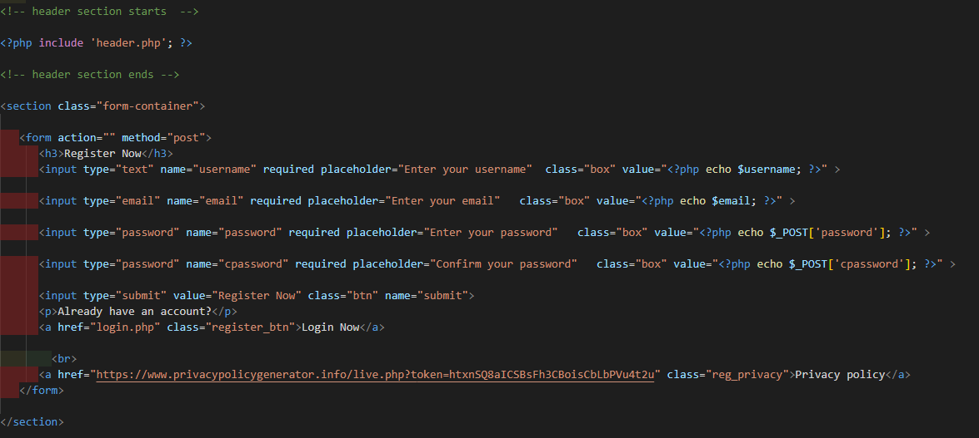

Figure 25:signup page HTML Code.



Figure 26:Interactive Navigation bar.

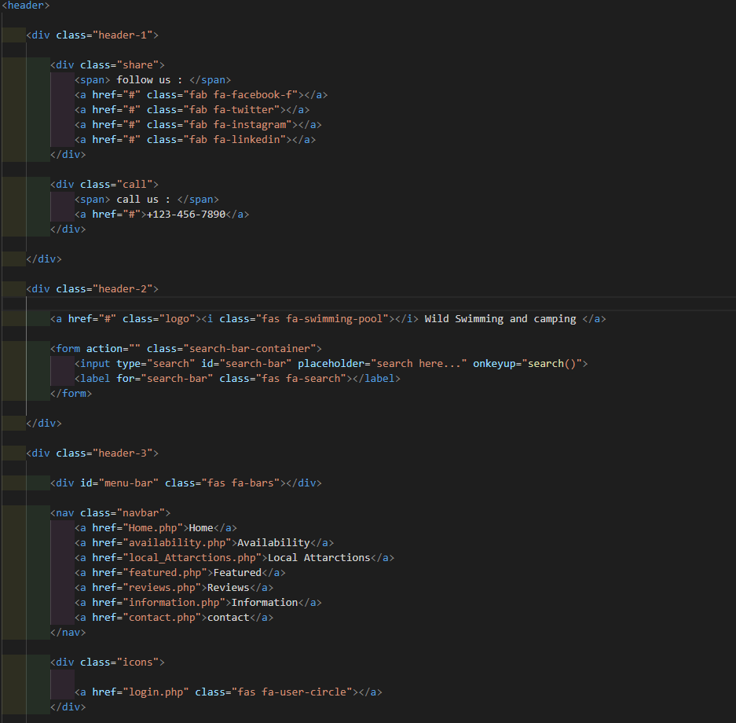.Figure 27:Interactive Navigation bar HTML.



Figure 28:Slide show.

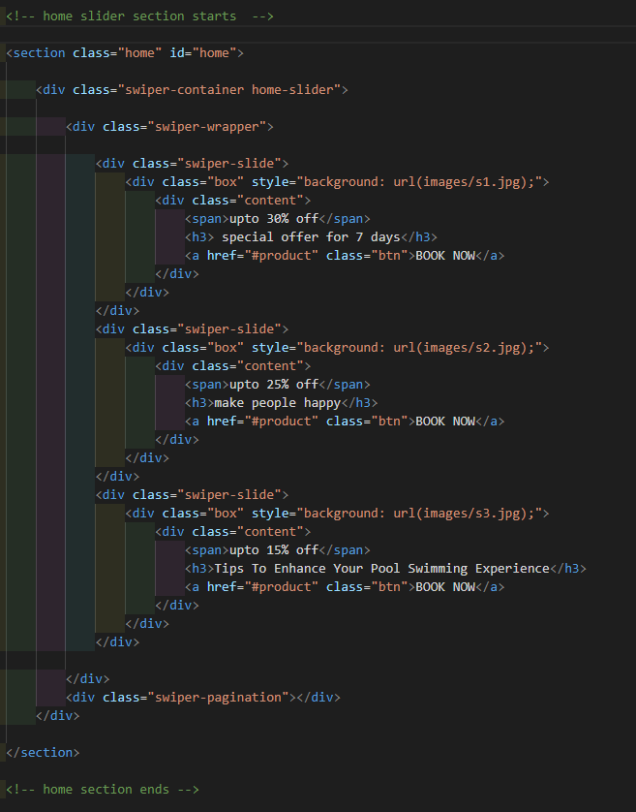

Figure 27: Slideshow HTML .



Figure 30: Search bar.

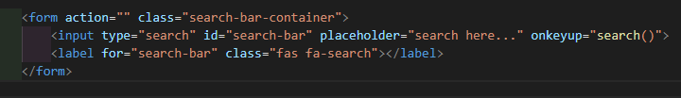

Figure 31: Search bar HTML.

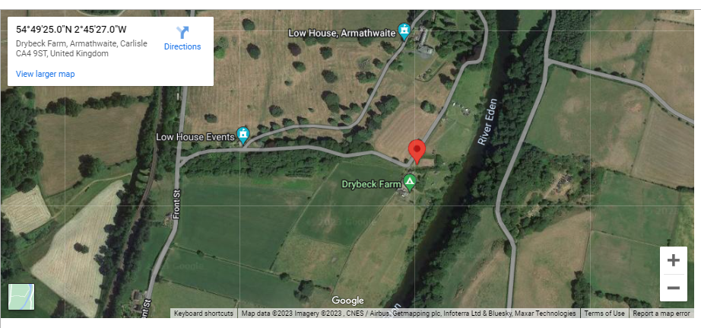

Figure 32: Location maps.

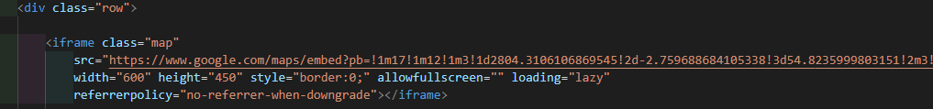

Figure 33: Location maps HTML.



Figure 34: Number of views counter.

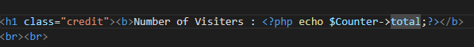

Figure 5: Number of views counter HTML.

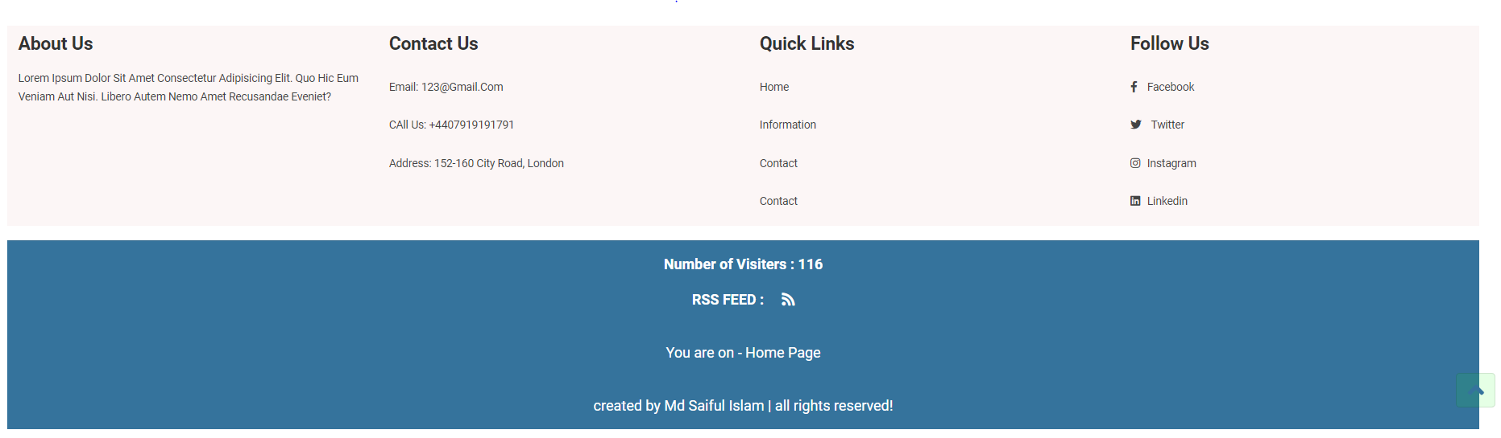

Figure 35: Footer which includes - you are here, copyright information and social media

buttons.

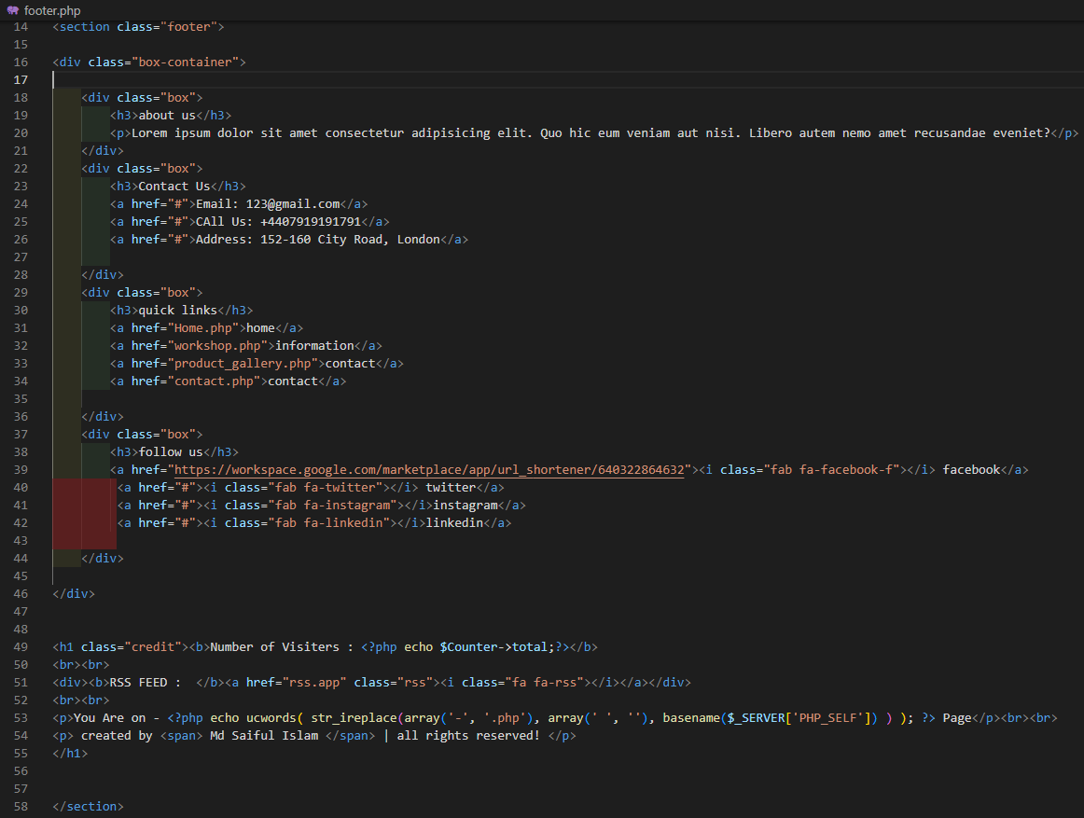

.Figure 36: Footer section HTML.

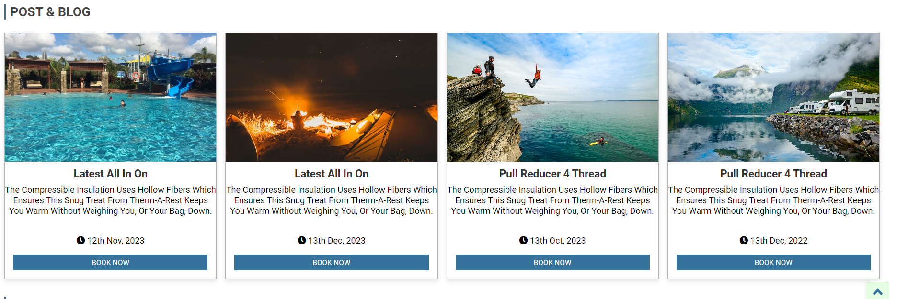

Figure 37:Relevant text and images across all pages.

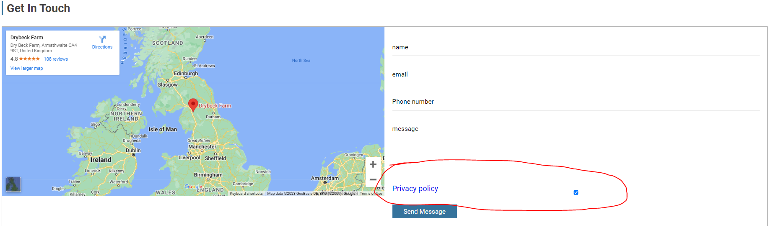

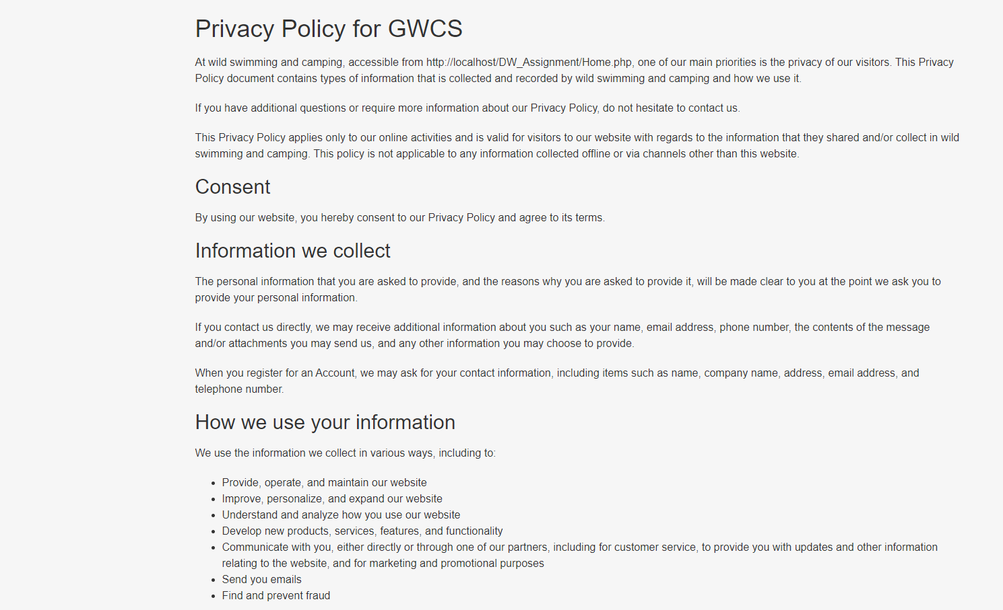

Figure 38:RContact us form (including privacy policy) HTML Page.



Figure 39:RContact us form (including privacy policy).

* **Two (2) different web services.**



Figure 40:Web service 1.



Figure 41:Web service 2.



Figure 42:You are here (page)



Figure 43:You are here (page) Code.

* **Be usable in TWO (2) different web browsers**

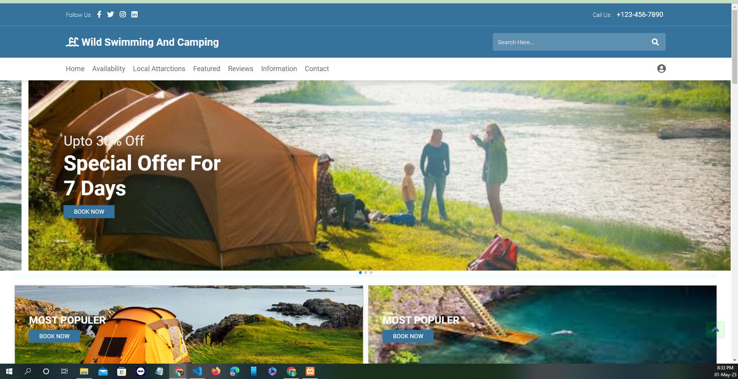

Figure 44:Google chrome browser view.

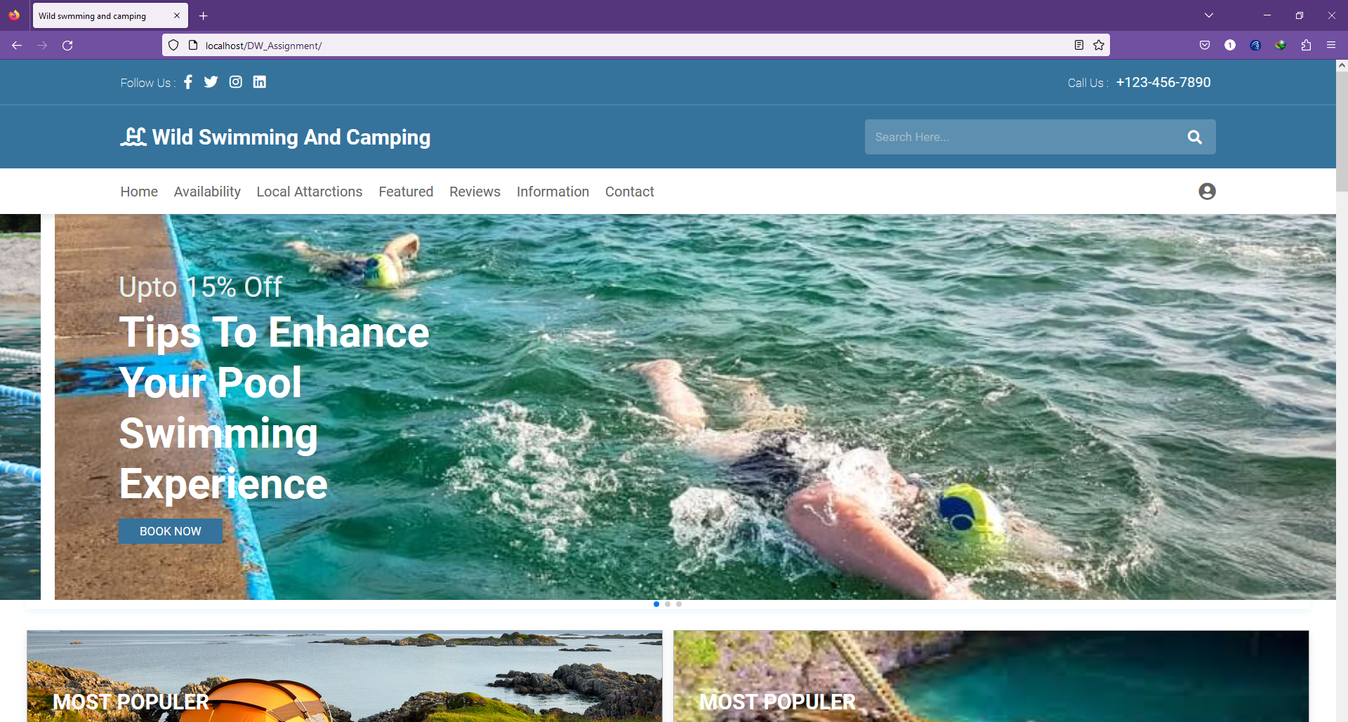

Figure 45:Firefox browser view.

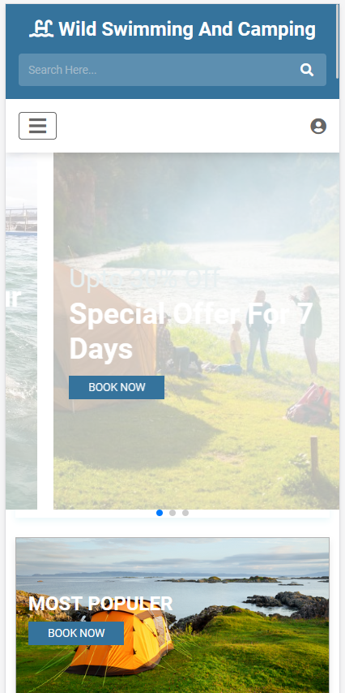

Figure 46:Firefox browser Mobile view.

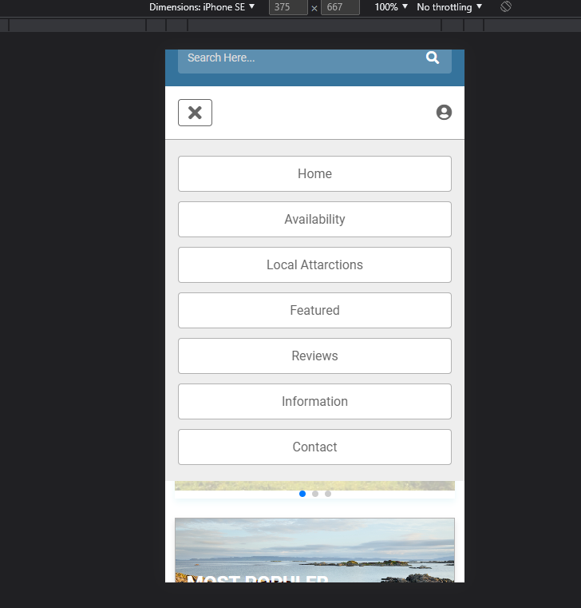

Figure 47:Google chrome browser Mobile view.

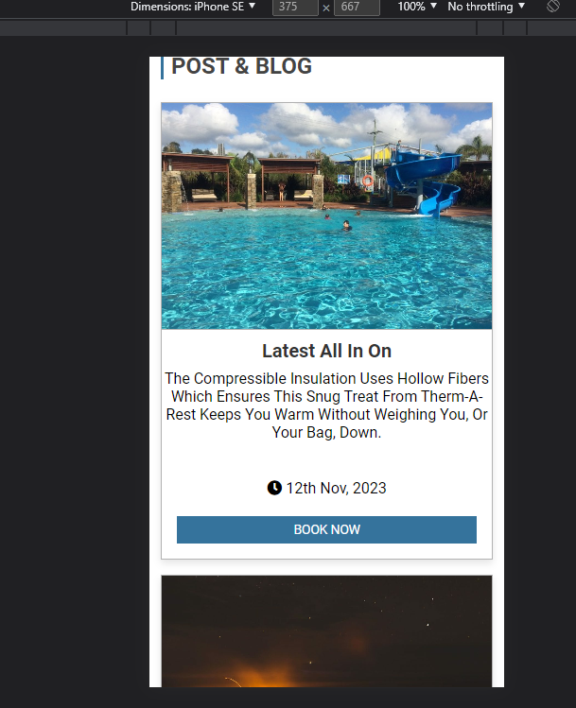

Figure 48:Responsive image and text sizes.

**Task -2 CSS and Database**

**All page CSS :**

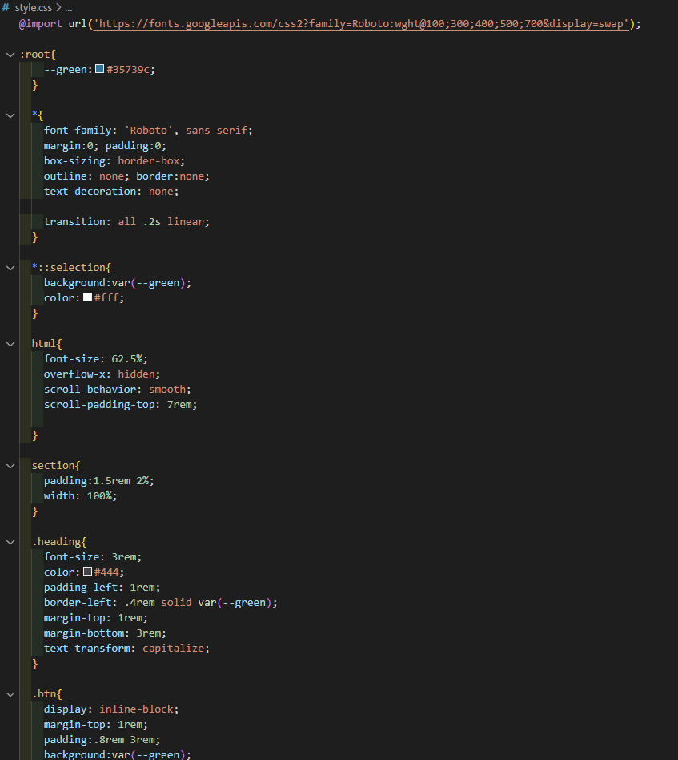

CSS Figure 1

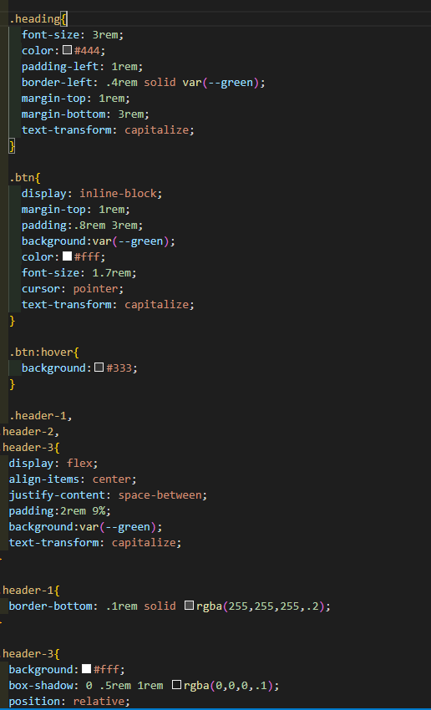

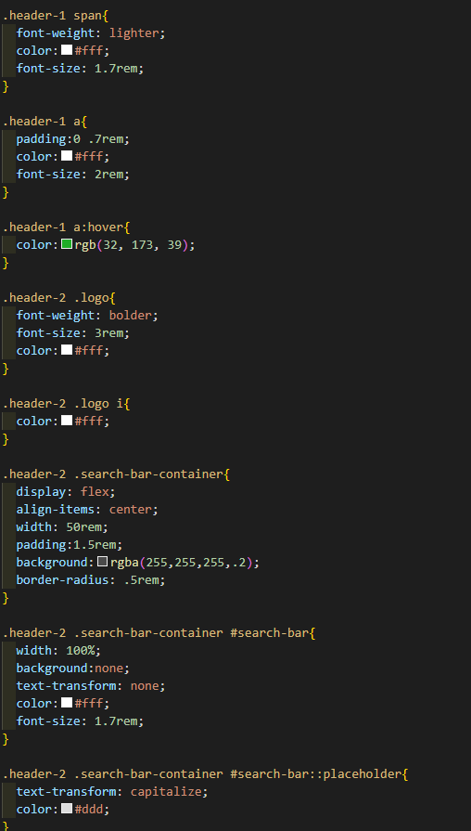

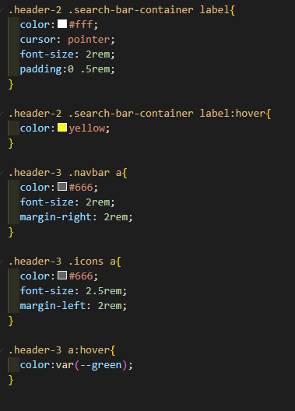

CSS Figure 2:header.

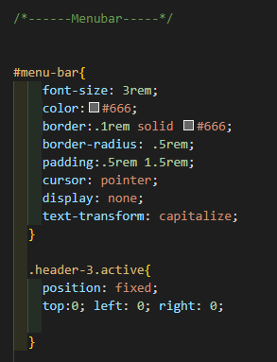

CSS Figure 3:Menubar.

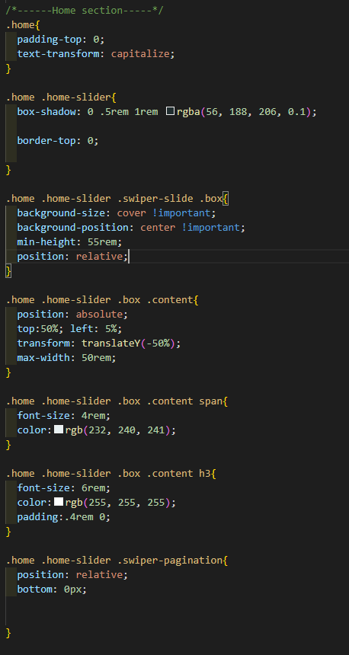

CSS Figure 4:Slider.

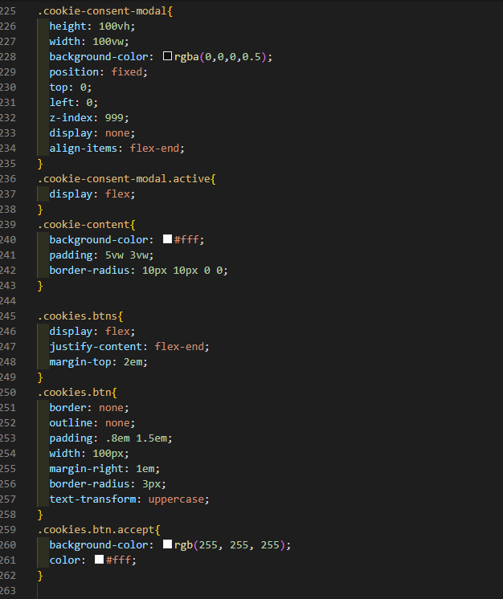

CSS Figure 5:Cookies.

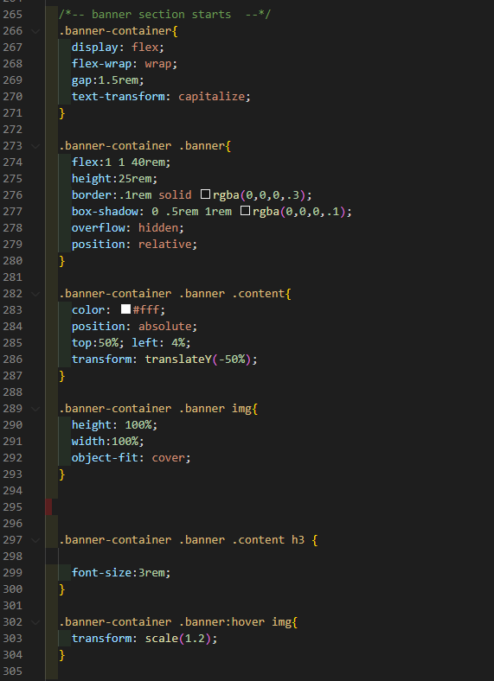

CSS Figure 6:Banner section.

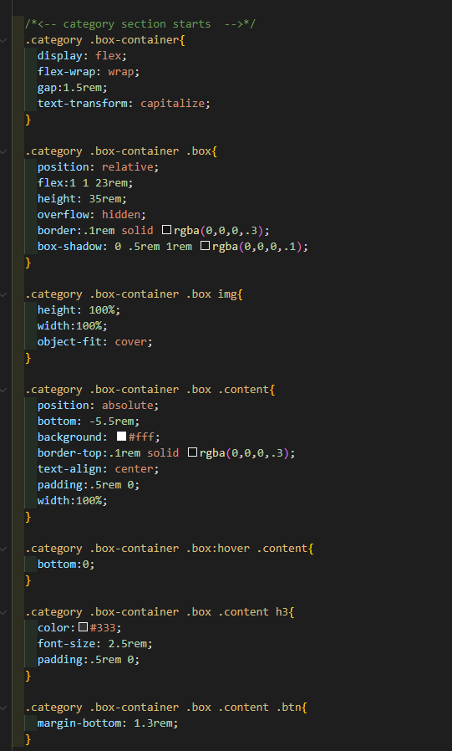

CSS Figure 7:category.

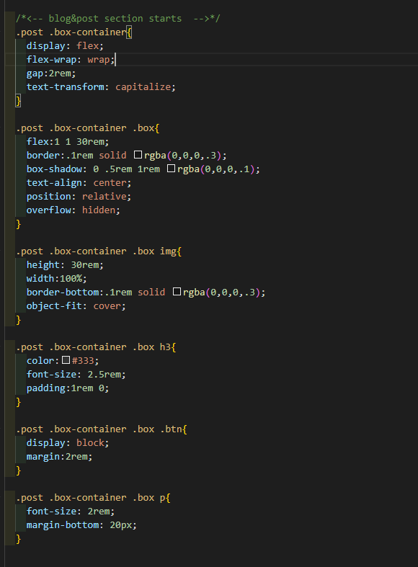

CSS Figure 8:Blog & Post.

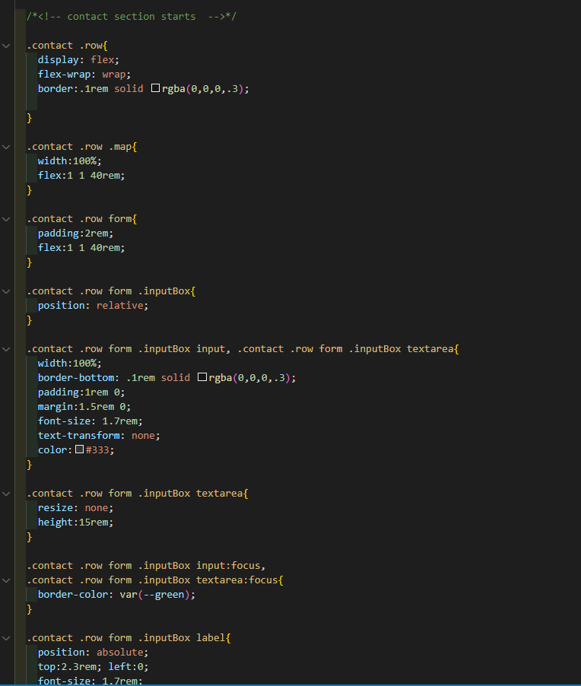

CSS Figure 9:Contact.

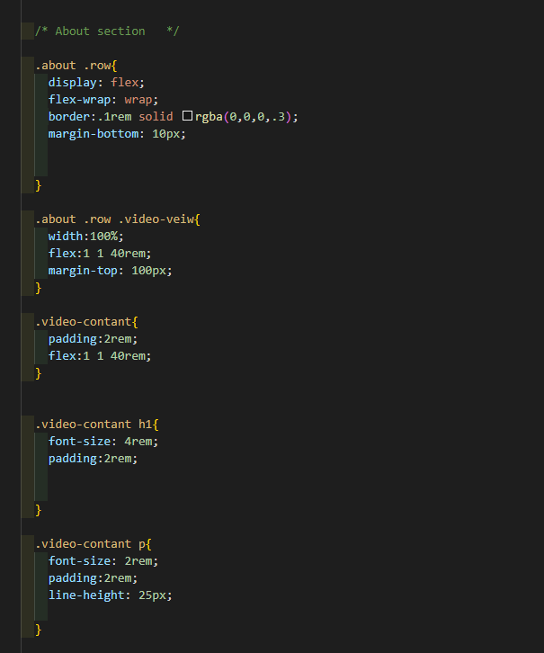

CSS Figure 10:About.

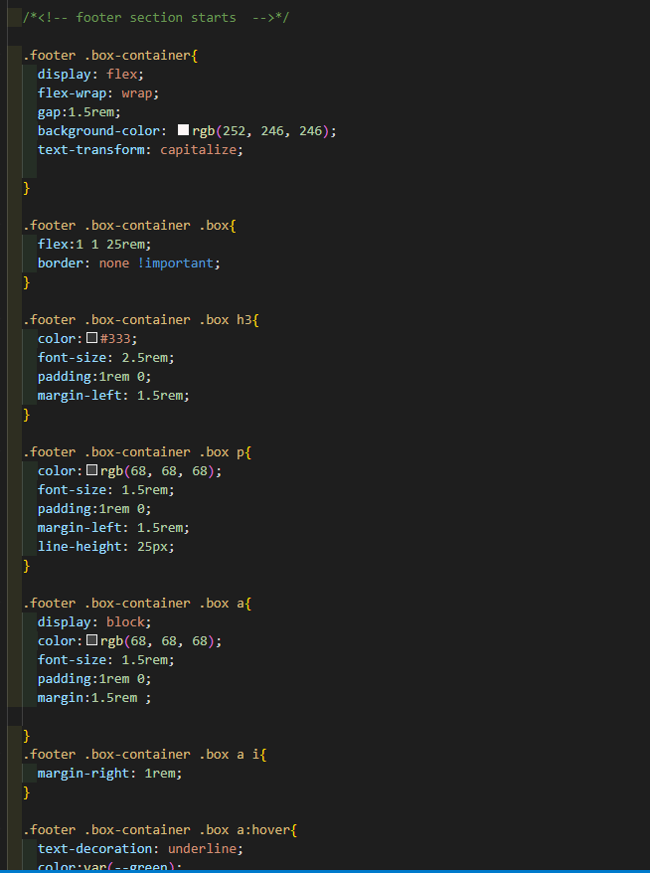

CSS Figure 11:Footer.

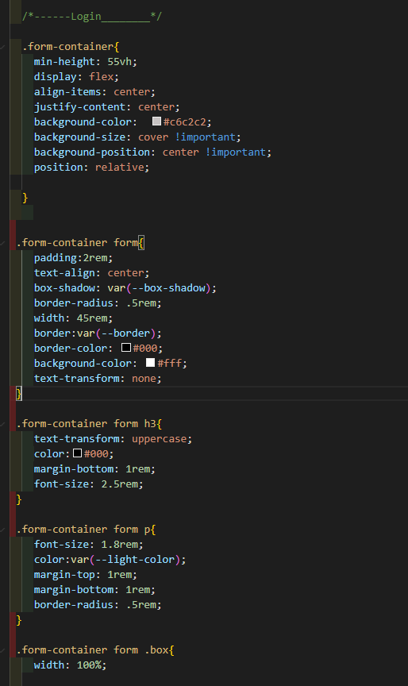

CSS Figure 12:Login.

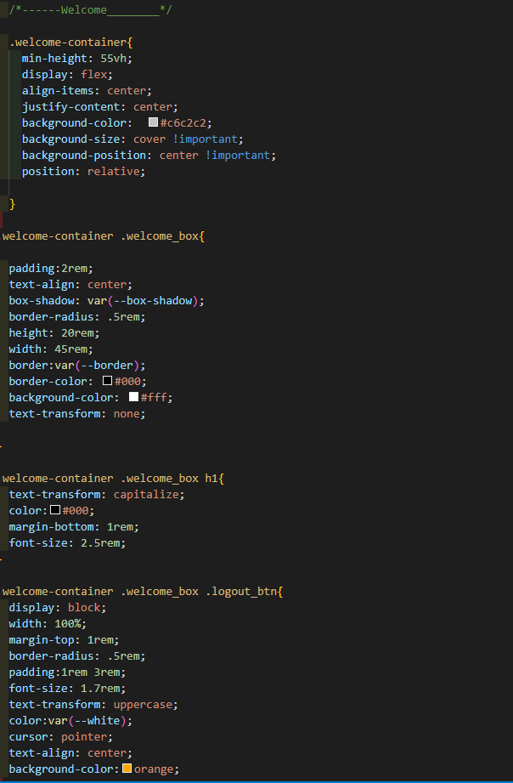

CSS Figure 13:user profile .

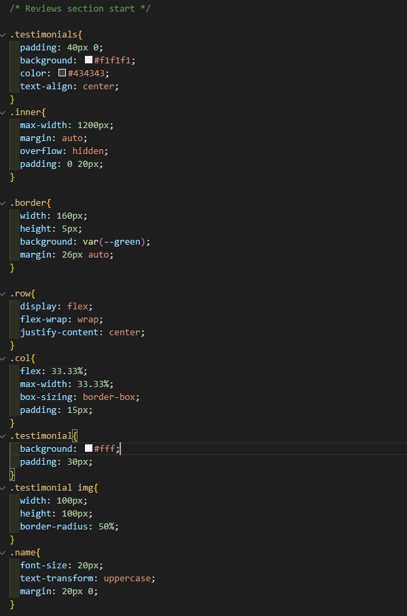

CSS Figure 14:Reviews .

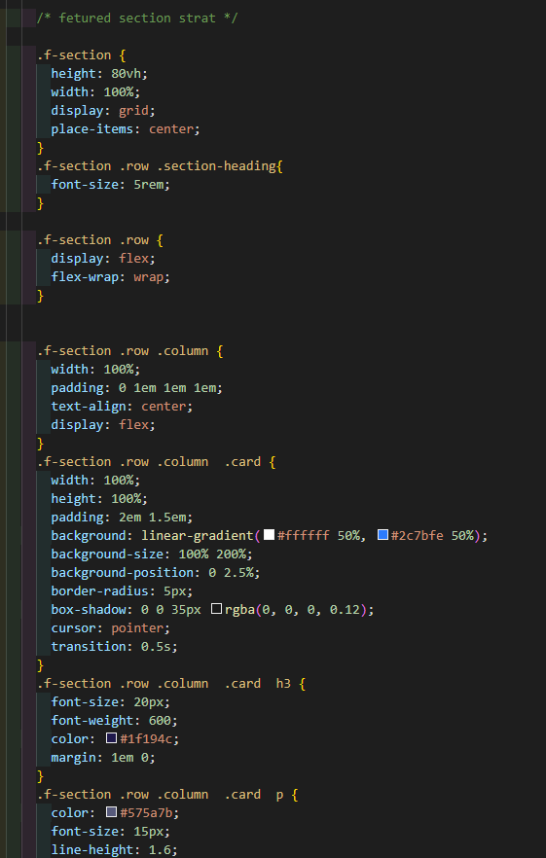

CSS Figure 15:Featured .

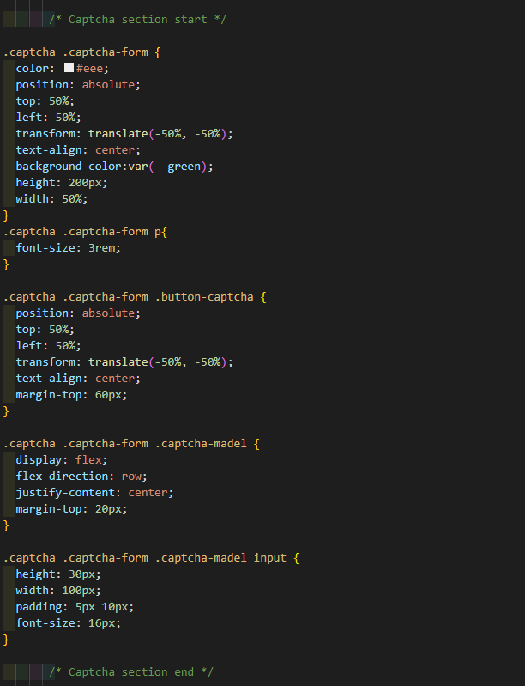

CSS Figure 16:Captcha .

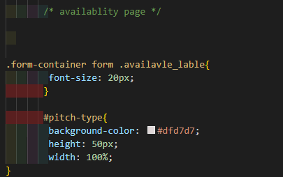

CSS Figure 17:Availability .

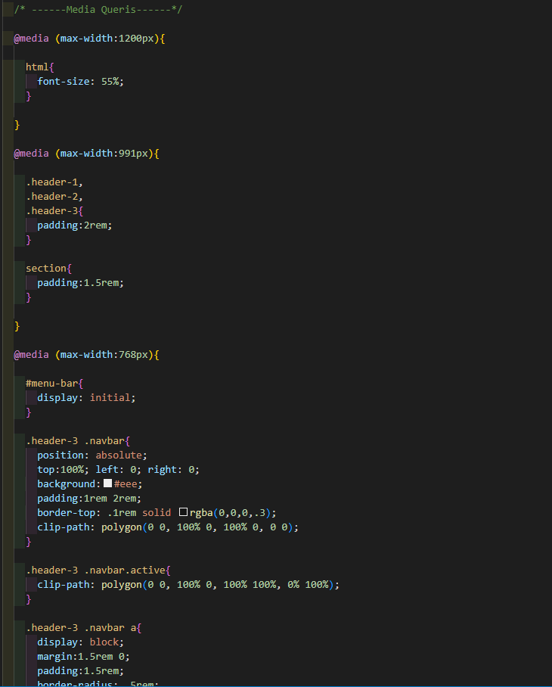

CSS Figure 18: Media Queries for responsive websites.

* **Database:-**

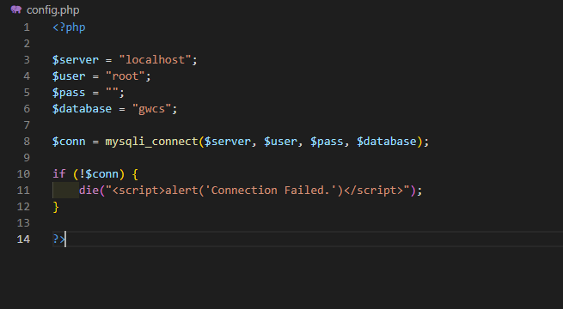

Figure 1:Database PHP.

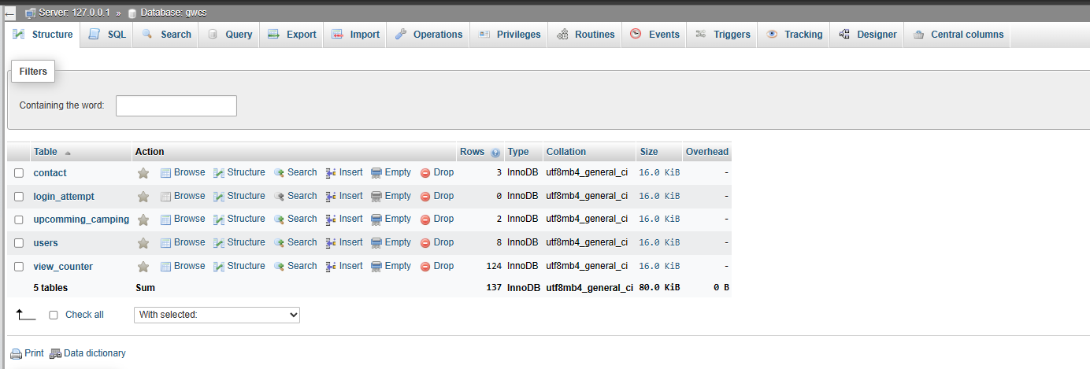

Figure 2:All tables .

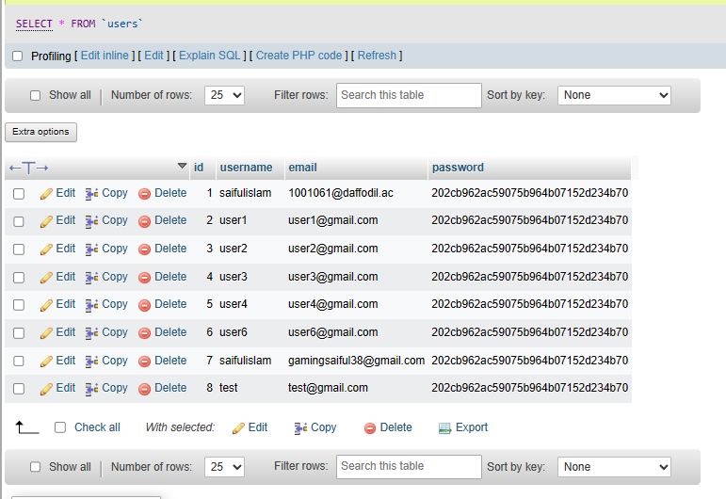

Figure 3:User tables.

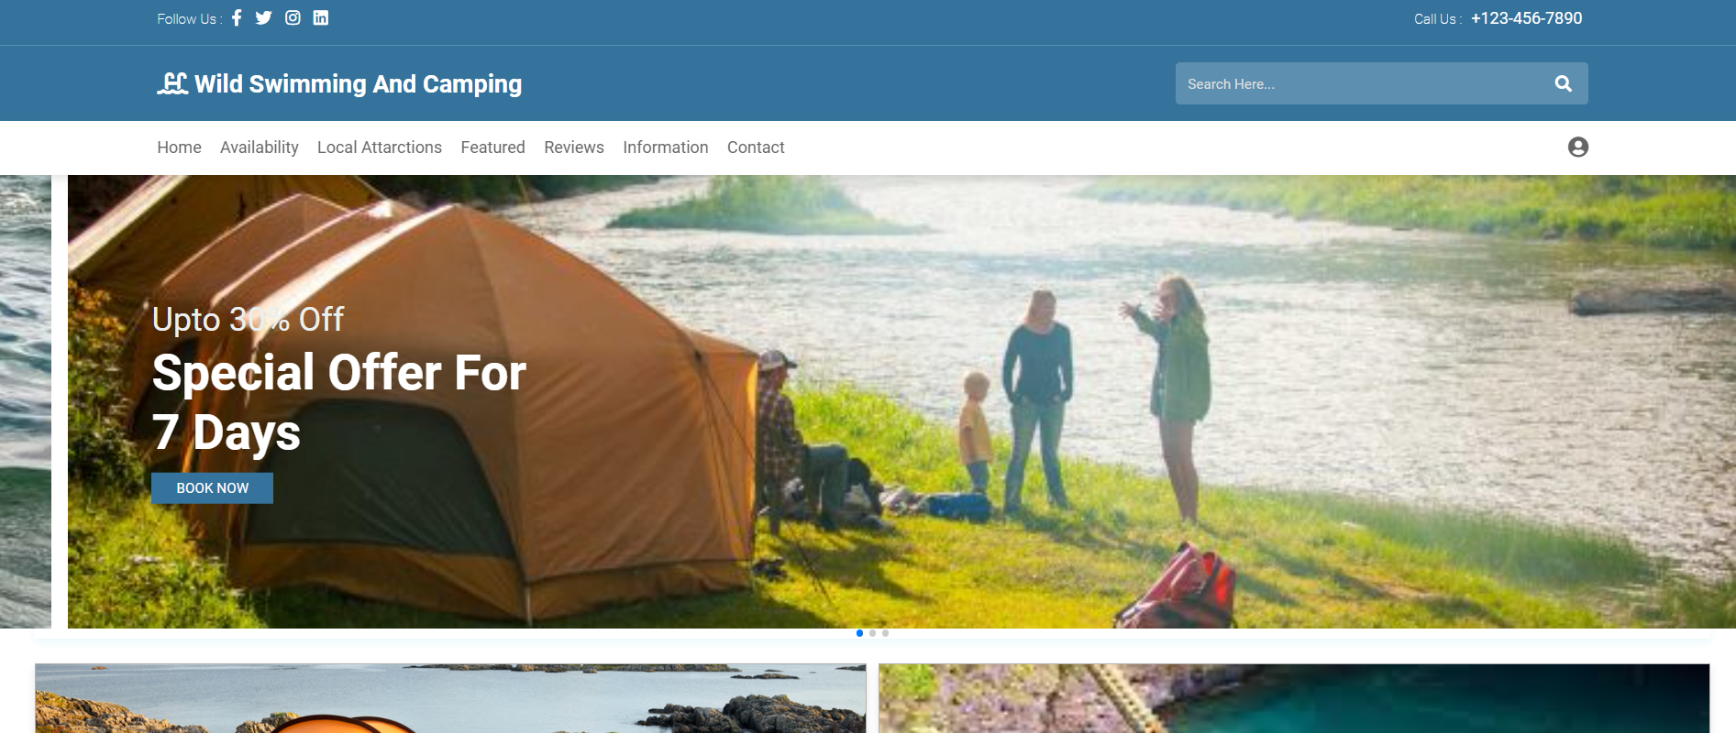

Figure 4:New user Registration fast.

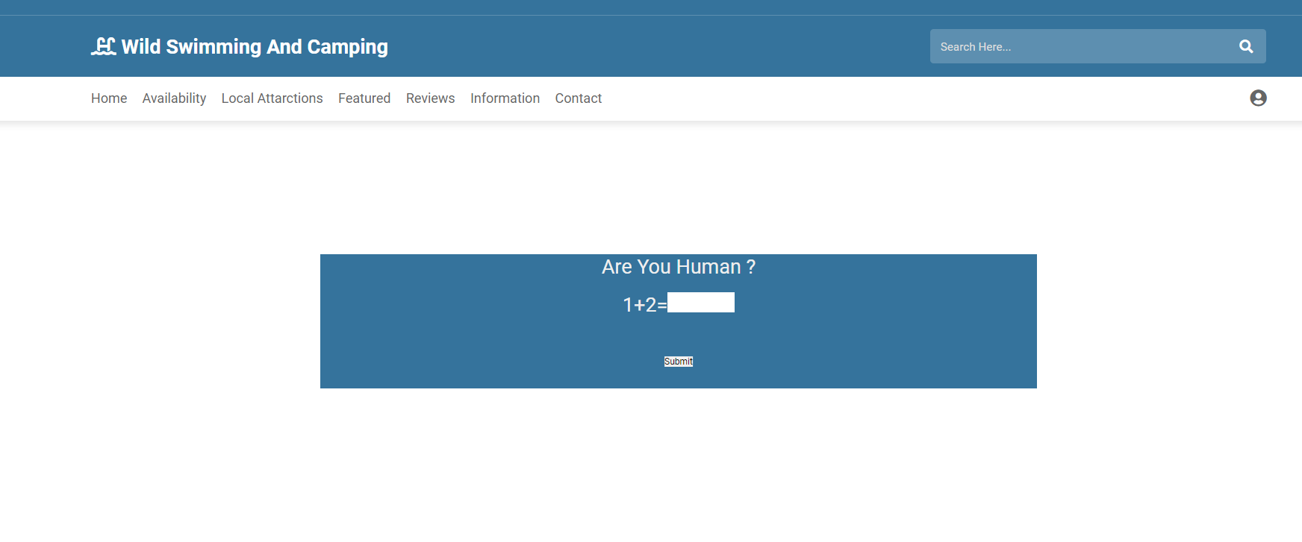

Figure 5:Complete captcha verification before login.

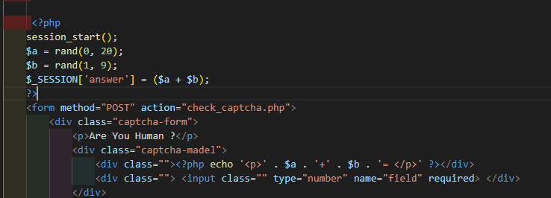

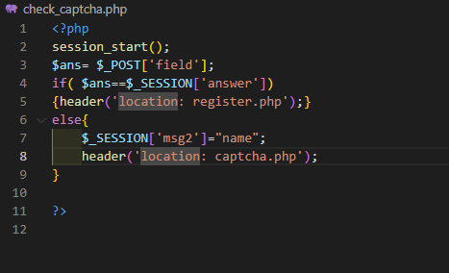

Figure 6: captcha verification PHP.

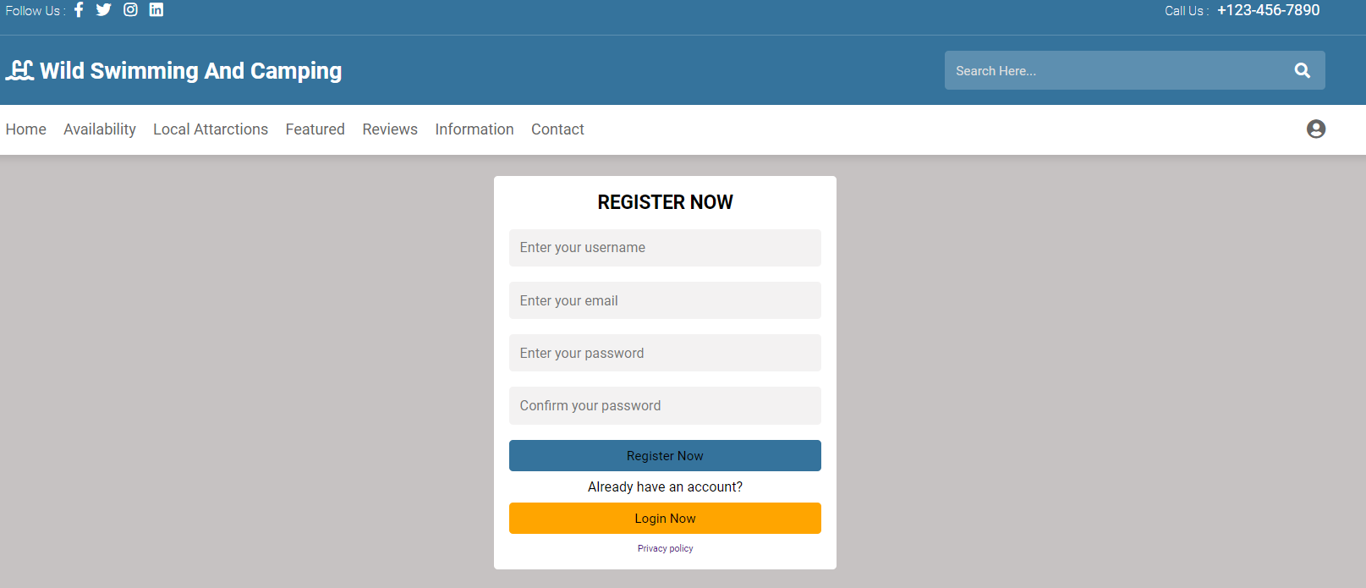

Figure 7:Register From.

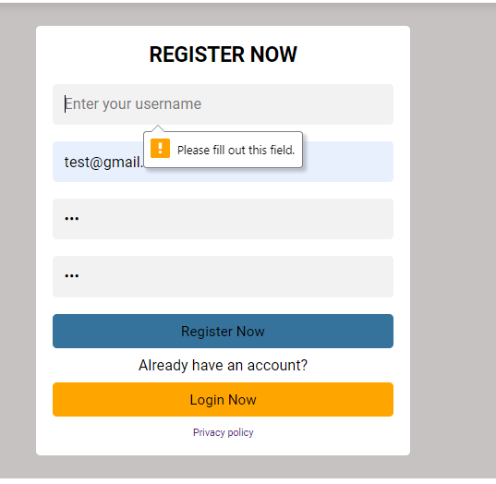

Figure 8: Required to fill all fields.

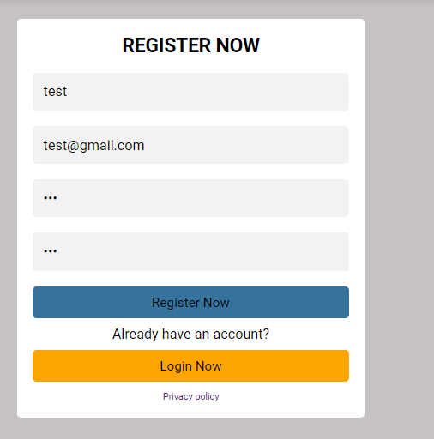

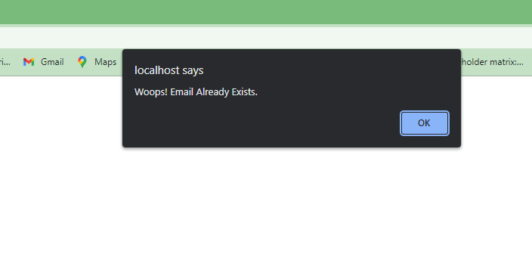

Figure 9:Complete Register Need unique Email.

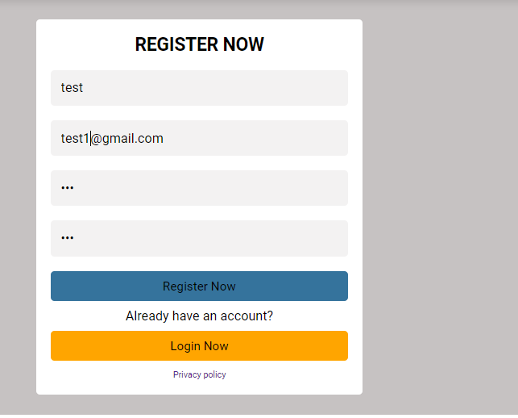

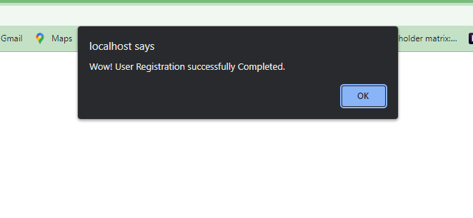

Figure 10:Complete Register With Unique Email.

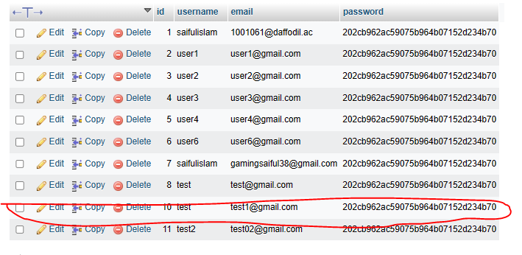

Figure 11:We can see new user data inserted into the database.

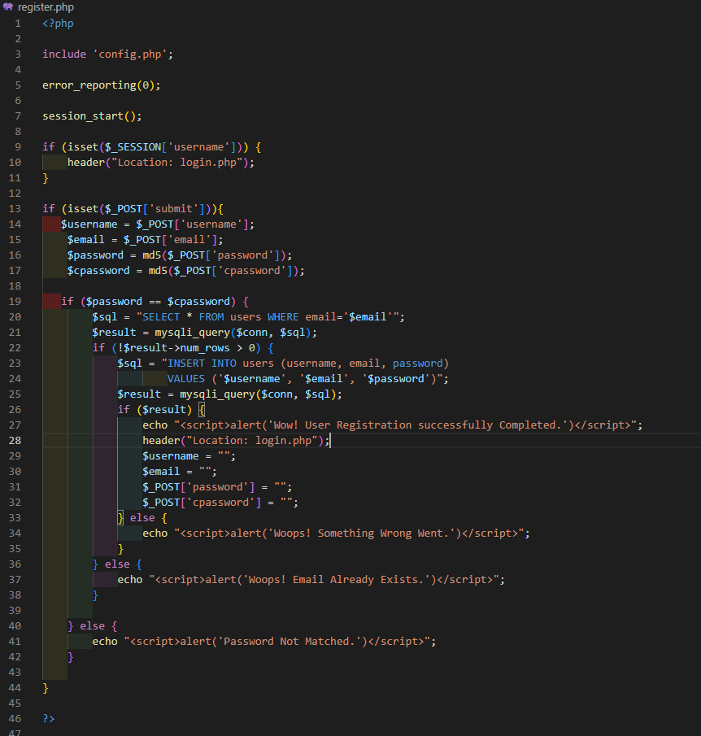

Figure 12:Register page PHP Code.

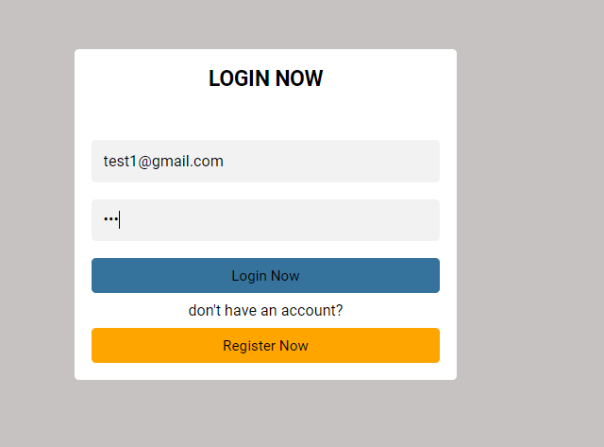

Figure 13:Login with new user Email and password.



Figure 14:Login successfully .

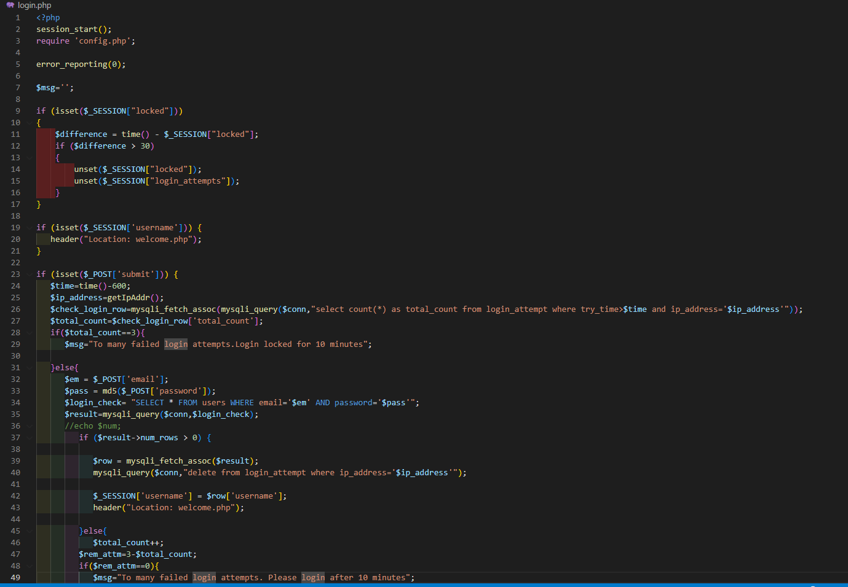

Figure 15:Login page PHP Code.

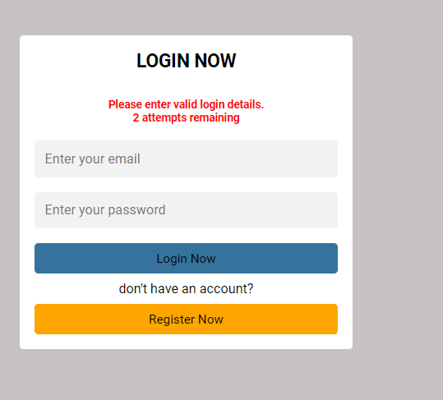

Figure 16:Login Attempts.

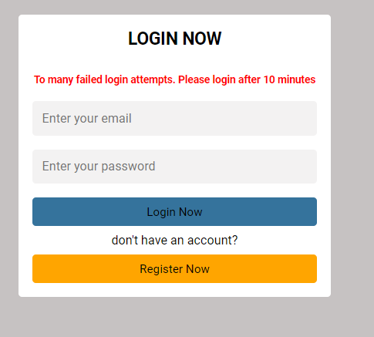

Figure 17:After 3 times Wrong information .

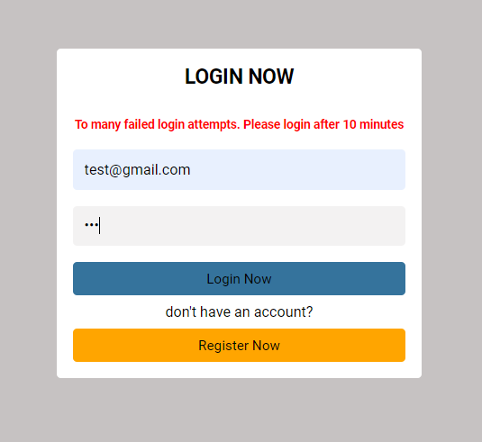

Figure 18:After 3 times Wrong information now given correct details.

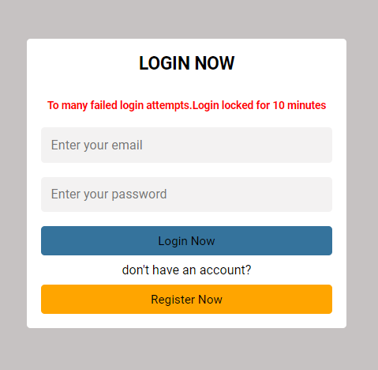

Figure 19:Locked login for 10 minutes.

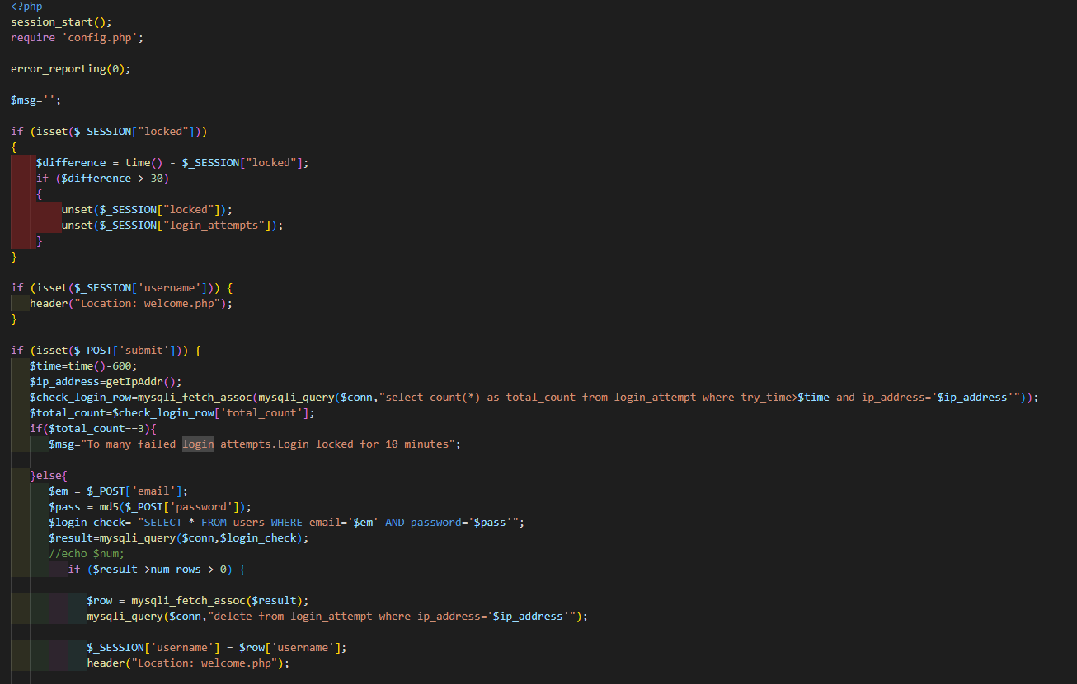

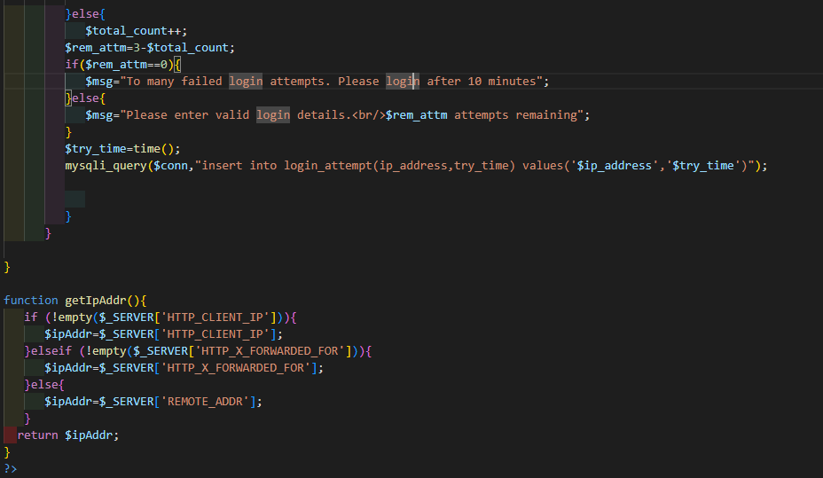

Figure 20:Login attempts PHP Code.

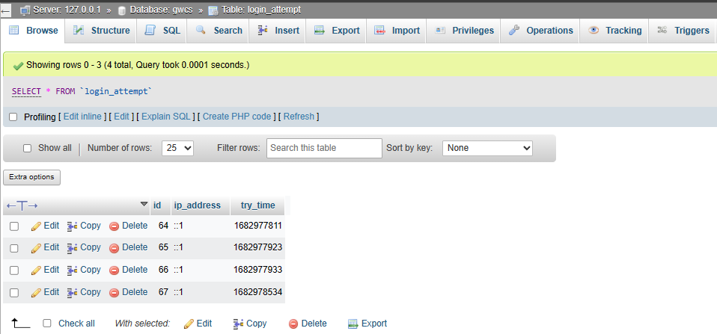

Figure 21:Login attempts Database Table.

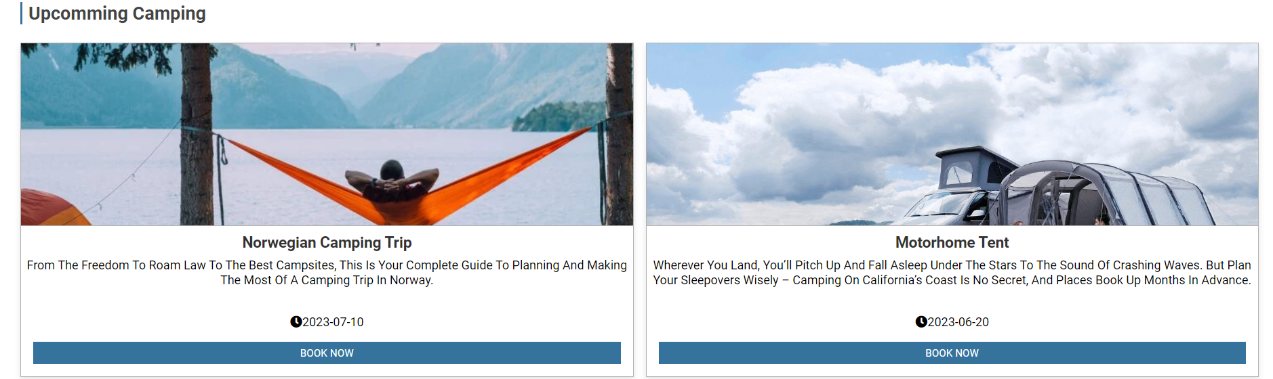

Figure 22:Upcoming camping fetch from database .

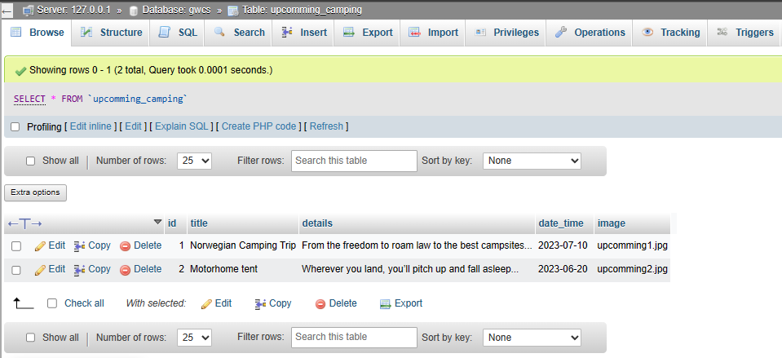

Figure 23:Upcoming camping database Table .

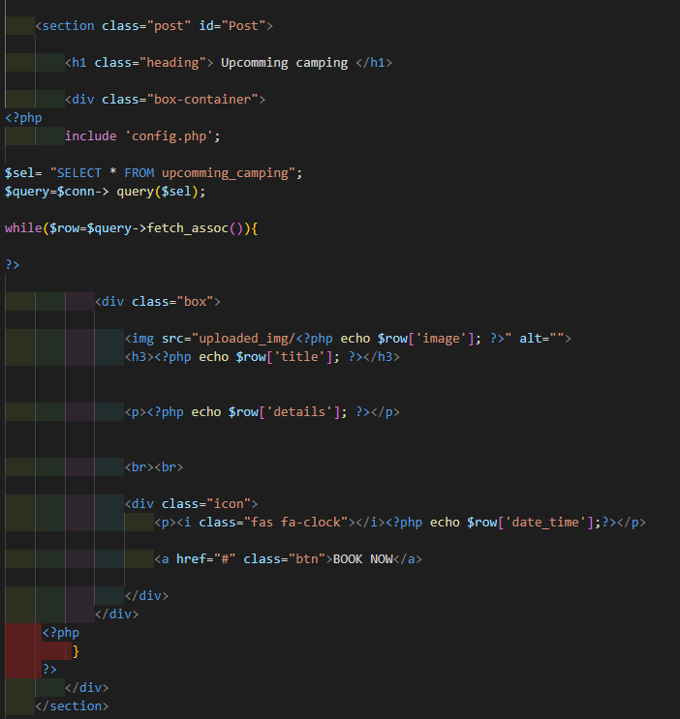

Figure 24:Upcoming camping PHP Code.

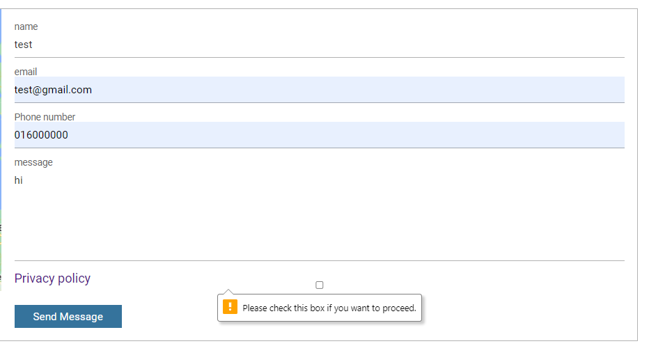

Figure 25:Contact from required accept privacy policy .

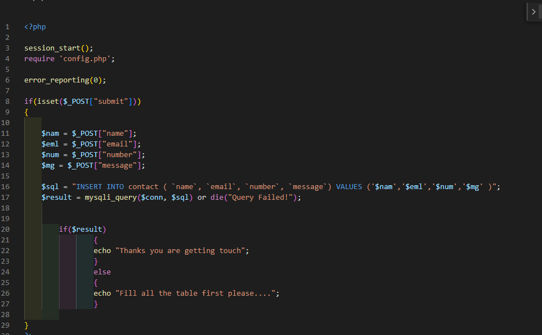

Figure 26:Contact from PHP Code.

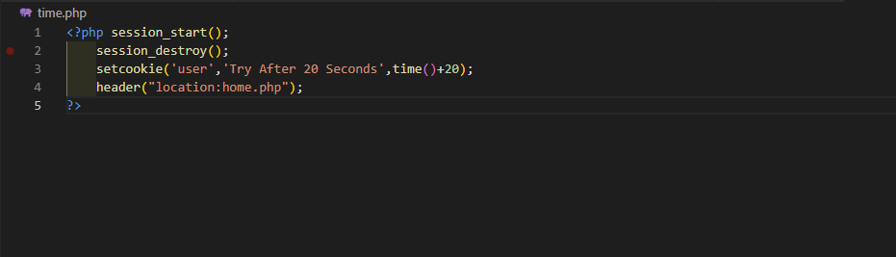

Figure 27:Login destroyed After 20 seconds.

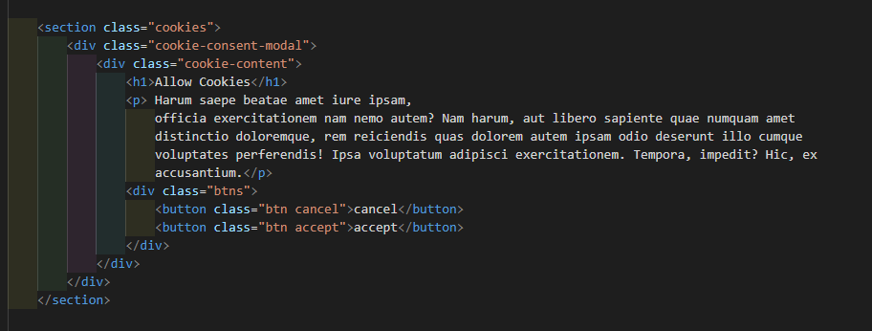

Figure 28:Cookie.

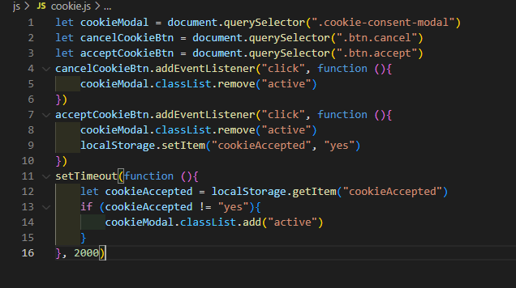

Figure 29:Cookies Javascript Code.

**Task-3 Critical Evaluation**

First, it is very important to make a website user friendly. User have to understand the function of

the web application. A website allows users to perform a wide range of tasks online. Such as, fill up form

for registration or login etc. Moreover it also allows user to make payments and communication with

others. The website of GWCS provide advantage to users for interact with external system and services,

like as a social media platform and payment gateway. Users can also gain data from different sources.

* Web applications have become an integral part of modern businesses, enabling

organizations like GWCS to communicate and interact more effectively and efficiently

with their customers. By integrating web services into its website, GWCS can provide

additional functionality beyond the capabilities of the website itself, allowing customers

to access external systems and data sources and automate processes to streamline

workflows. In order to create a successful web application, it is important to have a solid

understanding of HTML and CSS as these are the building blocks of web development.

HTML is used to structure and organize the website#39;s content, while CSS is used to style

and format the content, making it more visually appealing and easier to navigate. When

integrating web services into a website, it is important to choose the right services that

meet the specific needs of the organization and its customers. For example, in this

scenario. By harnessing the power of web applications and web services, organizations

like GWCS can offer their customers a more engaging and rewarding user experience,

resulting in increased customer engagement and retention.

* I have been using html to build my website. Html help me to provide a proper structure

and organization. It allow me to organize content into heading, paragraph list and

others. Besides, it provide support me to use multimedia content, such as image, videos

and sound in the website. I use forms, buttons and links, and maps using html. HTML

supports the creation of interactive elements such as forms, buttons, and links. This

allows users to interact with the website and perform actions such

downloading data, accessing other pages, and interacting with dynamic content.

* CSS is a part and parcel for every developer. It is essential to design a website. By

using CSS I can include font size, color, layout, image size and responsive design. It help

me to choose font, text resizing, contrast adjustment and so on. I use CSS to give a

perfect and consistent look to my website.i am also transitioning when hover text in up from under the image .for show more beautiful when i hover image then image show zoom. By using css font-family,margin,box-sizing,overflow-x,scroll-behavior,scroll-padding,padding,background-color,text-transform,justify,position,border,height ,width and more . My website can be used by mobile users because it is fully responsive .For mobile ,tablet i am using css on media quarry . overall this website is fully user friendly .

* For businesses to prosper in the current day, having a strong online presence has become more crucial. One such instance is the GWSC website, which makes use of two web services that are turning the tide for their business. Despite their being only two web services accessible, they fully accomplish the scenario's objectives. Users may make reservations and get information about the company's camping and wild swimming options on the website. The user experience is further improved by the website's responsive design on any device.

The location map web service is A standout feature, which allows users to search for campsites and pitches and offers maps and images of their locations. For customers who want to explore the neighborhood on the go, the location map online service is now mobile-friendly. As a result, website user engagement is likely to increase, which is good for business.

The RSS feed web service is a useful component of the website. Users may keep up with the most recent news and events pertaining to the company's offers by subscribing to the RSS feed. The links in the RSS feed take readers to several destinations where they may get comprehensive information about the chosen subject. Additionally, because RSS feeds are responsive on almost all device types, users can access the most recent information while on the go.

**TASK-4 Reflection:**

What?

As a web developer, I utilized HTML5 for structuring the website and CSS for designing and decorating the developed structure in the front end. To handle the back end process, I employed PHP and a bit of JavaScript. Although I was familiar with HTML and CSS, learning PHP and JavaScript was a completely new experience for me. Despite the challenges, it was an enjoyable and rewarding experience.

So What?

Initially, I encountered numerous issues while using PHP and JavaScript for back end logic. As a beginner, it was quite a hassle for me. I faced code errors, server errors, and syntax errors. However, I sought help from the internet and after conducting thorough research, I was able to overcome the problems and achieve the desired results.

Now what?

Developing this website broadened my knowledge of website development significantly. I am now capable of building such websites on my own, including both front end and back end. I learned how to create a responsive and dynamic website and add various features to it. If I am asked to build similar websites in the future, I will be able to do so with ease. However, next time, I will focus on making the website more dynamic and incorporating more logic to enhance the user experience and take it to a professional level.

**Conclusion:**

In conclusion, this assignment proved to be a challenging task for me as a beginner. The complexity of the task was increased as I had to not only create a static structure but also make it dynamic using PHP and a bit of JavaScript. It took me a considerable amount of time to comprehend the logic and incorporate it into the code. However, this experience has significantly enhanced my knowledge and will undoubtedly aid me in future projects. Overall, despite the initial difficulties, I am proud of the final result and consider it a valuable learning experience.